

**Faculty of Informatics and Computer Science**

**Computer Science**

**Machine Learning for Extraction and Classification of Adverse Drug Events from social Media**

By: Ahmed Hossam Ahmed Mohamed ElSabbagh

Supervised By

Associate Prof. Nahla Barakat

And Professor Khaled Nagaty

**June 2019**

Abstract

Adverse Drug Reactions/Events (ADR) are a harmful or unpleasant reaction caused by the use of medicinal product [1], these effects are studied through the science of Pharmacovigilance, the science and activities relating to the detection, assessment, understanding and prevention of these effects [2] [3]. The ADR caused by drugs after their release is considered a major health hazard, causing a large number of death, it is estimated that more then 6% of patients are hospitalized as a cause of serious ADRs, which is translated into more than 2 million patients, 0.32% of whom are fatalities or more than 100 thousands deaths in the US alone [4].

This project aims to research and find a good method to implement an Adverse Drug Reaction (ADR) detection program using machine learning based methods, with dataset collected from social media and/or medical forums.

The dataset will be extracted from specialized online forums using a crawler. The user data and some physical traits, like age, gender, weight, height and blood pressure will be extracted from the dataset using text mining techniques, pattern matching and sliding window. Using UMLS Metathesaurus medical concepts using the help of MetaMap, ADRs and diseases will be identified, and their presence or absence is as both features- as medical history- and classes for supervised learning to predict the possibility of being inflicted by an ADR, specifically or generally.

The dataset will be also tested with unsupervised association rule mining using word embedding and association rule mining, in order to find patterns and to find statistical relation between drugs and any ADR in question, and how it connect the user profile and medical history.

Acknowledgment

Deep and special thanks for my supervisor, Associate prof. Nahla Barakat, without whose guidance, suggestions and support, this project would never have been made.

Sincere thanks to prof. Khaled Nagaty, for his suggestions and encouragement in the making of this project.

Special thanks to my family, especially my brother Mohamed, for being a constant aid and guidance throughout my entire academic life.

The code for Apriori algorithm is partially taken from Usman Malik’s online tutorial from stack abuse, which referred to in the Apriori section.

Table of Contents

Chapter 1: Introduction 11

1.1. Overview 11

1.2. Scope and objectives 12

Chapter 2: Related Work 13

2.1. Background 13

2.2. Literature Survey 13

2.2.1. Traditional ADR Detection Methods 13

2.2.2. Scope of research 13

2.2.3. Finding Datasets 14

2.2.4. General Text Processing Techniques: 14

2.2.6. Supervised Learning 17

2.2.7. Hybrid and Unique 20

Chapter 3: Methodology and Implementation 23

3.1. Acquiring the dataset 23

3.1.1. Subjects to consider 24

3.1.2. Data retrieval 25

3.2. Build Dictionary: 25

3.2.1. Subjects to consider 26

3.3. Unsupervised Algorithms 27

3.3.1. Association with GloVe 27

Implementation Details: 28

3.3.2. Association with Apriori 29

Implementation Details: 30

3.4. Supervised Learning 30

3.4.1. Preparing the dataset 30

3.4.2. Dataset Imbalance 32

3.4.3. Preparing Classifiers 35

Chapter 4: Results and Discussion 43

4.1. Unsupervised Algorithm 43

4.1.1. GloVe Results 43

4.1.2.1. Drugs and ADR relation 43

4.1.2.2. Related Concepts Discovery 47

4.1.2. Apriori Results 50

4.1.2.1. MedHelp 50

4.1.2.2. Discussion on MedHelp 51

4.1.2.3. AskAPatient 51

4.1.2.4. Discussion on AskAPatient 52

4.1.2.5. Discussion on Apriori 52

4.2. Supervised Learning Results: 53

4.2.1. Legends 53

4.2.1. Summarized Discussion Supervised Learning 54

4.2.1.1. SMOTENC: Before and After 54

4.2.1.2. Random Forests vs SVM vs Naïve Bayes 55

4.2.1.3. Feature Filtering 56

4.2.1.4. Predicting the potential number of ADRs and Diseases per user 57

4.2.1.5. Discovering ADRs and Diseases 58

4.2.1.6. Predicting the presence of any possible ADR 59

4.2.2. First Experiment 60

4.2.2.1. Random Forests 60

4.2.2.2. SVM 66

4.2.2.3. Naïve Bayes 67

4.2.3. Second Experiment 68

4.2.4. Third Experiment 71

Chapter 5: Conclusion 72

5.1. Conclusion 72

5.2. Future Work 73

References 74

Appendix 1 – Figures of other results 82

Appendix 2 – Tables of other results 93

Table of Figures

Figure 1 Text Classification Procedure [30] 12

Figure 2 Results from Literature survey N.1 [11] 16

Figure 3 Results from Literature survey N.2 [11] 17

Figure 4 Data flow from acquiring to usage 21

Figure 5 Acquiring dataset using crawler 21

Figure 6 Steps for building dictionary 23

Figure 7 cost function for the GloVe Co-occurrence matrix 25

Figure 8 SMOTE: All Data [67] 31

Figure 9 SMOTE isolated minority [67] 31

Figure 10 SMOTE KNN [67] 31

Figure 11 SMOTE random new record by distance [67] 31

Figure 12 SMOTE new Data [67] 32

Figure 13 SVM [77] 36

Figure 14 Bayes Rule [73] 36

Figure 15 Gaussian distribution [74] 37

Figure 16 Confusion matrix 37

Figure 17 Classifier flow 40

Figure 18 Tensorflow vector projector 41

Figure 19 SMOTE VS NO SMOTE Hypertensize Disease 52

Figure 20 RF vs SVM vs Naive Bayes 53

Figure 21 Filtering vs No Filtering 54

Figure 22 Number of Diseases and ADRs 55

Figure 23 Pain predictions with and without medical history 56

Figure 24 ADR prediction 57

Figure 25 Hypertensive Disease RF With SMOTE 59

Figure 26 Hypertensive Disease RF Without SMOTE 59

Figure 27 RF Pain with SMOTENC 60

Figure 28 RF ADR Count with SMOTENC 61

Figure 29 RF Disease Count with SMOTENC 62

Figure 30 Hypertensive disease RF with Feature Filtering and SMOTENC 63

Figure 31 Pain SVM with SMOTENC 64

Figure 32 Pain NB 65

Figure 33 Drug Predictions Random Forests 67

Figure 34 Drug Family Prediction Random Forest 68

Figure 35 Pain prediction random forests 69

List of tables

Table 1 Dataset Description 30

Table 2 Feature Description 30

Table 3 Data arrangements used for the experiments 35

Table 4 GloVe Result (a) 43

Table 5 GloVe Result (b) 44

Table 6 GloVe Result (c) 45

Table 7 GloVe Result (d) 46

Table 8 GloVe Result (e) 47

Table 9 GloVe Result (f) 48

Table 10 Legends to describe the Datasets 52

Table 11 SMOTE VS NO SMOTE Hypertensize Disease 53

Table 12 RF vs SVM vs Naive Bayes 54

Table 13 Filetring vs No Filtering 55

Table 14 Number of Diseases and ADRs 56

Table 15 Pain Prediction with and without medical history 57

Table 16 ADR prediction 58

Table 17 Feature Description 59

Table 18 RF Hypertensive disease with SMOTENC 60

Table 19 RF Hypertensive disease without SMOTENC 60

Table 20 Pain with SMOTENC 61

*Table 21 RF Pain without SMOTENC* 61

Table 22 RF ADR Count with SMOTENC 62

Table 23 RF Disease Count with SMOTENC 63

Table 24 Hypertensive Disease RF with Feature Filtering and with SMOTENC 64

*Table 25 Pain SVM with SMOTENC* 65

*Table 26 Pain NB* 66

Table 27 Dataset description 2 67

*Table 28 Drug Prediction Random Forests* 68

Table 29 Drug Family Prediction Random Forest 69

*Table 30 Pain prediction random forests* 70

Chapter 1: Introduction

# Overview

Adverse Drug Reactions/Events (ADR) are a harmful or unpleasant reaction caused by the use of medicinal products [1], these effects are studied through the science of Pharmacovigilance, the science and activities relating to the detection, assessment, understanding and prevention of these effects [2] [3]. The ADR caused by drugs after their release is considered a major health hazard, causing a large number of death, it is estimated that more then 6% of patients are hospitalized as a cause of serious ADRs, which is translated into more than 2 million patients, 0.32% of whom are fatalities or more than 100 thousands deaths in the US alone [4].

There are many steps taken Through medical trials to find the ADRs, however some people may not have the same side effects as others and therefore not all ADRs that affect all different patients appear until phase IV trials -postmarketing trials- especially since most medical trials are concentrated on certain demographics, therefore are many uncertainties of the effect of the drugs on any given population [5] [6], and despite the many mediums offered by the FDA to report ADR (FAERS, MERP, MedWatch) [3], 90% of the ADR are in fact under-reported [7].

However, a new field of pharmacovigilance via social media has been introduced in recent years, as there are many disease support networks (DailyStrength and MedHelp), patient forums (AskAPatient) and miniblogs(Twitter) [8], where patients are involved in sharing their experiences with certain drugs, with many of them and their caregivers actively read these experiences [3]. Many data mining techniques were adapted to extract potential ADRs of drugs through text mining and machine learning, allowing many researchers not only a new way research ADRs, but also help them find new ADRs they had not known to have previously existed in some drugs or find earlier occurances than previously reported [3] [9].

# Scope and objectives

This project aims to research and find a good method to implement an Adverse Drug Reaction (ADR) detection program using machine learning based methods, with dataset collected from social media and/or medical forums.

It also focuses on unsupervised learning with word embedding, to try to find the most relevant terms used in the dataset, in order to find patterns within the dataset that could help in identifying common ADRs.

It will also include a section using association rules, where the relations between ADRs, diseases and drugs will be found, this will identify the most common diseases and their potential cause.

Finally the main focus will be on supervised learning, testing three techniques, namely Random Forests, SVM and Naïve Bayes. To try to predict the potential drug causing medical issue, or predict the chances of an ADR occurring based on the user profile and their medical history.

Chapter 2: Related Work

# Background

There has been a lot of work related concerning ADR datamining, the most prevalent methodologies include lexicon-based pattern mining [5] [6] [9] [10] and supervised machine learning [11] [12] [13] approaches [3], however there are also rare cases of hybrid systems [14] [15], and partially supervised implementations [16]. The evaluation of these techniques was done mainly using three metrics, F-Score, Recall, and Precision [17] [18] [19].

# Literature Survey

## Traditional ADR Detection Methods

Electronic post marketing pharmacovigilance has traditionally been applied through FDA Adverse Event Reporting System (FAERS) [20], MedWatch [21] and the Institute of Safe Medication Practices Medication Error Reporting System (MERP) [3]. These methods however are voluntary for the public and healthcare professionals, meaning that data could be missing or incomplete, and clinical narratives are limited to researchers affiliated with medical research centers [3]. However, due to the widespread use of social media, the wider knowledge and the convenience of its use, patients have been more comfortable sharing their experiences and looking for answers as shown in a survey by Pew Research Center [22]. This is why many researchers have been trying to find ways to mine social media for ADR information.

## Scope of research

There has been two types of research, direct ADR research as surveyed by [3], which focuses on trying to discover a relation between a given drug and any ADRs, the second is drug-drug-interaction (DDI) as surveyed by [23], which focuses on the side effects of consuming several drugs in the same time. This project will focus on the first type of research.

## Finding Datasets

The first obstacle regarding ADR research is to find the necessary data. The data used in all projects is comprised of social media posts with mentions of drug names, these posts may or may not contain mentions of ADR related to the drug name. The posts are arranged into a corpus of data which is used to train and evaluate machine learning and pattern mining approaches [3] [6] [9] [10] [11] [12] [13] [14] [16]. The social media in question are twitter, the data of which is available at Arizona State University [3] [11] [14] [24], and DailyStrength [25], MedHelp [26], PatientsLikeMe [27], Yahoo! Forums [16], Medications.Com [28] and AskAPatient [29]. Using either purpose built crawlers [5] or API [12] to get the data.

## General Text Processing Techniques:

Generally, the following sequence of text processing techniques were used to make the data usable for learning process, with variations and different tools used to achieve it, the texts were split in the punctuations and whitespaces, creating tokens (Tokenization), stemming is applied to remove similar words or turn them to a simpler form (training, trainer, trained = train), stop words (a, and, but) are removed completely. The tokens are then turned into vectors, from which certain features are extracted and used in the learning algorithm [30].

Many researchers used lexicon for comparison, provided by UMLS Metathesaurus [31] , SIDER [32], MedEffect Canada [33] and manually allocated colloquial terms.

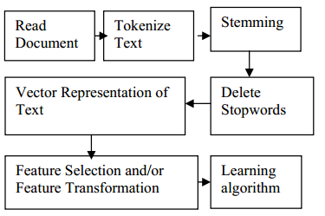

Figure 1 Text Classification Procedure [30]

1. **Lexicon-Based Techniques**

The first real attempt to create a pharmacovigilance program was in 2010 by Leaman et al. [5]. The lexicon is extracted from UMLS Metathesaurus [31] , SIDER [32], MedEffect Canada [33] and manually allocated colloquial terms [5]. It used a purpose built parallelized crawler to extract comments from DailyStrength [25], bringing about 3600 annotated comments and 450 reserved for evaluation, the information was taken for the following drugs, carbamazepine, olanzapine, trazodone, and ziprasidone [5]. The comments were annotated for adverse effects, beneficial effects, indications and other terms [5], where the following tools are using in text processing, Java (Tokenization), Snowball implementation (Stemming) [34], Jaro-Winkler measurement [35] (Similarity for misspelling) [5]. A basic lexical similarity comparison was applied, where a sliding window of tokens (size = 5) was go over the tokenized text, comparing them with lexical terms in the dictionary, pairing them in an assignment problem [5], the similarities were summed and normalized with the result by the number of tokens in lexical term [5]. The closest verbs were used to categorize the mention, where verbs like “taking” was an indication, since ADR are targeted, Indications, beneficial effects and others were filtered out [5]. 1260 adverse effects, 391 indications, 157 beneficial effects and 78 other, for a total of 1,886 annotations [5]. For the evaluation, Precision = 78.3%, recall = 69.9%, for an F-Score = 73.9%, not all known ADRs were recognized [5].

The following lexicon methods that followed use association rule, a data mining approach that tries to find statistical relation between drugs and ADRs, the goal is to find enough minimum support and confidence constraints [36]. The research by [6] [10] were among the first to apply this method.

The first research [6], which was made by the team working on [5], tried to match a comment with certain grammatical patterns in order to find the mention of ADR and detecting whether a person is actually inflicted or not [6]. To achieve that, the DailyStrength [25] dataset corpus was used, with an additional 3290 records were added for a total of 6890 records, including the original 1886 annotations from the previous research and using the same dictionary as before and the same drugs [6]. Then to solve the problem, it follows three steps: 1) Term Sequence Generation, the sequence of words in which an ADR is mentioned is stored in a file, each line in the file has the ADR replaced with ADR keyword, part of speech (POS) tagging is performed using the Stanford parser [6] [37]. Some POS were kept (like verbs) using Wordnet [6] [38]. Thus a term is created. 2) Frequent Rule Identification, Apriori tool [39] (which implements Apriori Algorithm) is used to mine association rule, where a term like “make PRP RB CC =>ADR” (which is a combination of verb make and POS tags) occurs when ADR is reported [6]. 3) Frequent Pattern Generation, where patterns based on Frequent Rule Identification are generated, with short patterns and patterns with placeholders after ADR being excluded. Precision = 70.01%, recall = 66.32% for an F-Score = 67.96%, with minimum support = 4, maximum=6, minimum number of terms per rule=4, other tunings and replacements in the input were tried, but this was by far the best result in all the attempts [6].

While [10] tried to detect ADRs through data in parenting sites using disproportionality techniques using the concepts discussed in the three Dutch examples methods [10] [40], the drugs used for this research were amoxicillin, paracetamol, ibuprofen, Bactrim, cetirizine, azithromycin, bacitracin, loratadine, xylometazoline [10], the data was collected from eight parenting web sites in a seven year period (2005-2012) [10], a total 1290 posts were collected, 900 annotated and 300 kept in reserve [10]. A database was created to keep drugs and posts, drugs were organized with their generic names and Anatomical Therapeutic Chemical (ATC) codes [10]. Used UMLS Metathesaurus [31] for biomedical vocabularies, and other resources such as European Agency for the Evaluation of Medical Products (EMEA), Medicines and Medical Devices Agency of Serbia (ALIMS) [41], the DrugBank Database [42], and MetaMap [10] [43], which is a lexical system that maps text to concepts in UMLS Metathesaurus. The following disproportionality measures were used to qualify drug safety: reporting ratio (RR), proportional reporting ratios (PRR) [10], reporting odds ratios (ROR) and information component (IC), each of these measures find the association between ADR and drug. The evaluation of this method resulted in precision = 75.3%, recall = 64.7%, and F-measure = 69.599% [10].

The research by [9] was unique as it tried to not only identify the ADR, but also identify when it was first mentioned [9], all using tensor decomposition to assist in the classification, having used tensors as data containers instead of matrices, greatly helping in missing data and helped identify some ADR mentions before the official FDA announcement [9]. The main advantage of this approach is that it does not require expert annotation for the data [9]. Matrix Based Technique (MBT) was compared to the proposed Tensor Based Technique (TBT). External resources are used for item extraction, mainly Consumer Health Vocabulary (CHV) for drugs and ADR lexicon [9]. Temporal factor is considered important for ADR detection and monitor association rule [9], which is why the association will be made based on a time period of a year, with value p being time window, and q being overlapping year, several combinations of both were tired to compare with TBT [9]. After the association rule mining is done with temporal analysis for each ADR, a matrix of drug x time is made where each cell is the lift measure between ADR and Drug under specific year [9]. TBT introduces using a tensor (3D matrix) between drug, ADR and time, using CANDECOMP/PARAFAC (CP) decomposition technique [9]. Tensors allow the observation of dataset in 1 year time window without overlapping, so data from 2001 and 2002 are used in the same vector, averaging the results from both years [9]. Dataset about 20 drugs were extracted from 500 threads each drug from MedHelp [26] totaling 16344 threads ranging from 1997 and 2011 [9]. Evaluation measures were not determined, but apparently several ADRs were discovered by TBT as opposed to MBT, and some of the existing ADR were discovered to have been mentioned earlier than when it was alerted by the FDA [9].

## Supervised Learning

Next is supervised learning approaches, most ambitious ADR detection system try to track them through twitter or a mix of twitter and other sources, trying to use the large data set that can be provided through twitter [11] [12] [13]. Among the three research SVM, Naïve Bayes, and Maximum entropy were the most commonly used and evaluated.

The first to create a model that follows this approach is [44], which tried to use an ensemble of classification algorithms to classify the dataset on several stages, namely Support Vector Machines (SVM) with RFB kernel and Naïve Bayes (NB), using messages in Yahoo! Forums as dataset (exact size not determined), it used two feature sets: general vocabulary, and meta-features with specialized lexicons from MedDRA [44] [45].

The research made in [11] tried to research the ability to use multi-source dataset corpus, mainly three, twitter with data provided from Arizona State University [24], using 10822 tweets. 1082 of which were annotated by experts using the Inter Annotator Agreement (IAA) using Cohen’s Kappa [11] [46]. DailyStrength [25] with 10617 posts were used (23.7 % contain ADR mentions). And the ADE corpus which contains 23516 phrases with 29% containing ADR mentions, the corpus is not social media but it was used as a proof of concept that the system introduced can analyse data from any source [11]. Three supervised classifiers were made to test the data, Naïve Bayes (NB), Support Vector Machines (SVM), and Maximum Entropy (ME). To perform pre-processing, Porter stemmer was used using implementation by NLTK toolkit [11] [47], POS tagging was done using Stanford parser [37] and twitter parser [48]. UMLS concepts were identified using MetaMap [11] [43]. Synonymous terms were identified with WordNet [11] [38]. The features were by how often a change happens, so if an ADR is reduced, a good change happens and vice versa, so the feature set is built by identifying these changes using a sliding window on the phrase, the features are More-Good, More-Bad, Less-Good, Less-Bad [11]. Two other features are lexicon related derived from Leaman’s [5] lexicon, the two features in question are the Boolean feature of presence or absence of ADR mention, and the numeric feature of the 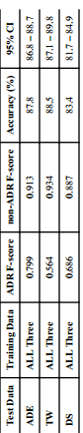number of times an ADR is mentioned, they also collect a topic based feature using Mallet tool [11] [49], the features are the topic mentioned and the sum of the relevance score [11]. Other features include: length of the text, the presence of certain tags from Stanford parser. To implement Naive Bayes (NB) and Maximum Entropy (ME) Weka tools are used, for SVM they use LibSVM implementation [11]. The SVM uses RBF kernel. Several combinations of the dataset were used to test the program, giving varying results, but the after combining all the datasets and testing them on the test data, it outperformed all the others, the results are shown in this table [11].

Figure 2 Results from Literature survey N.1 [11]

Also not all features have shown improvement as indicated by this table [11]. Where removing a feature tends to cause a drop in performance, except Synonyms (Syn-set) and topic model, have limited to no effect on the datasets (Except ADE corpus) [11].

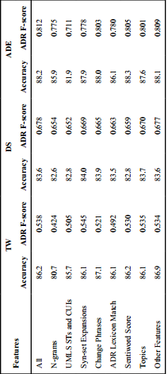

Figure 3 Results from Literature survey N.2 [11]

This research[12], Tried to not only identify ADRs but drug users, implementing two SVM classifiers, one to first identify users of five cancer drugs (still on trial) on Twitter , and the other to identify which ADR did they suffer [12]. The dataset acquired was is a 2 billion tweet collection collected using the Twitter API collected by [50] [51] for a different study [12]. For this study, the Tweets were reduced to four fields, 1) ID, 2) User ID, 3) Timestamp, and 4) text. The features extracted from the Tweets are textual and semantic [12], textual features include Bag-of-Words (BoWs), number of hasht-tags in the document, number of reply tags, number of negating words, the number of URLs, the number of pronouns, and the number of occurrences of the drug names or synonyms [12]. The semantic features are those derived from the UMLS [31] concepts extracted using MetaMap [43]. Trying to limit the data by choosing specific keywords more specifically the number of semantic type and group. After some trials, the Apache Lucene information retrieval library [52] parallelized with Amazon Cloud E2C was used. This lead to having the dataset limited to 239 potential users of the drug, 72 of them were confirmed. The evaluation of the classifiers was vaguely defined, but what is clear is that the first classifier had a prediction accuracy of 0.74 and an Area-Under the-Curve (AUC) of 0.82, and the second got an accuracy of 0.74 and AUC of 0.74 [12].

In [13], the works of the previous study was criticized over the technical aspect of using 72 sized dataset for both training and testing and not using the classifiers to classify more raw Tweets [13], it also criticises the lack of mentioning for the overall results, as well as using investigational drugs (still on trials) as it is not recognized whether the tweeter is using placebos or the real drugs [13]. With that in mind, the drugs chosen (Duloxetine, Gabapentin, Baclofen, Glatiramer, Pregabalin) have been chosen for being in the market for a number of years. This time the Tweets were mined manually of the period of 80 days using Twitter API (Which does not allow searching for posts older than 2 weeks) for a total of 6829 tweets, removing matching brand names of the drugs to peoples’ names and using only English tweets [13]. The features used were personal pronouns and sentiments derived from the NLTK [47], this is because the study required having “personal experience” tweets as opposed to “non-personal” tweets, according to the study; personal experience is expressed more often with pronouns. Using this principal, three classifiers were made, Naïve Bayes, SVM and Maximum Entropy (ME) [13]. ME was the most superior at precision= 0.866, Recall=0.842 and F-Measure=0.848, SVM’s result was precision= 0.856, Recall=0.810 and F-Measure=0.820, and Naïve Bayes was precision= 0.858, Recall=0.827 and F-Measure=0.835. Using 600 tweets for training and 285 for testing [13].

## Hybrid and Unique

Of mixed solutions, a mixed unsupervised and supervised learning [14] system (called ADRMine) had been developed. Data was provided by DailyStrength [25] and twitter using 81 drugs. The system used the same data provided in [24] which was used by [11]. Expert annotators annotated the posts and matched it with IAA’s Cohen’s Kappa [46], with the gold standard includes only reviews with complete IAA. The result is 4720 reviews from DailyStrength (+1559 test) and 1340 tweets (+444 test). An additional 313833 DS reviews and 397729 drug related tweets were gathered in a total 711562 postings to form an unlabelled set which would be used in unsupervised learning. A lexicon was generated using the previously mentioned tools UMLS [31] and SIDER [14] [32]. Concepts are extracted using Conditional Random Fields (CRF), a CRF classifier is used to extract ADR concepts from user sentences using CRFsuite implementation [53], turning them into individual tokens, beneficial effects were also identified as it was noted that including them improves performance of ADR extraction [14]. The CRF features extracted include context features: the 3 tokens before 3 tokens after and current token (Spelling correction was done with Apache Lucene [52]). ADR lexicon: a binary feature that shows whether or not current token is included in the lexicon [14]. POS: generated with Stanford parser. Negation: Features that indicated that the token is negated using syntactic dependency rule [14]. The other feature extracted is the learning word embedding, the embedding is a meaningful real-valued vector of configurable dimension (between 50 and 500), these vectors were generated using Word2vec tool [54], which learns the embedding based on the word’s contexts in different sentences, then a K-Mean clustering operation is performed to cluster the words into n (=150) different clusters (Each cluster has some common words, like one only including ADR or only including drug names or dates) [14]. Seven features are defined based on the generated clusters, which are the cluster numbers of the current token, the three preceding and the three following tokens. ADRMine’s CRF classifier was compared to 4 extraction techniques (SVM, Lexicon-based, and two simple baselines based on MetaMap). The system proved superior to the other techniques, reaching an F-Score= 0.821 for a recall=0.784 and precision=0.860 for DS dataset and F-Score =0.721 for Recall=0.682 and Precision=0.765 for twitter. It was concluded that the lexicon, POS and negation features did not add a significant contribution with a huge dataset as it did with smaller dataset [14].

There was only one example of hidden Markov Model [15], the study describes three type of sources for ADR information, biomedical sources (books, journals, magazines, drug package labels) which may not be up to date, most accurate [15]. Clinical sources (patients’ data) which are not free and are limited by ethical, legal and social constraints, may also be inaccurate. Online Forums are the most inaccurate, but they are the most numerous, up to date and totally free, refers to many other works found in the survey [15]. The data was extracted from Medication.com [28] and steadyHealth.com [55] using JSoup crawler, collecting 8065 posts from Medication and 11878 from SteadyHealth [15]. To extract relationships between entities, the information extraction module is made, consisting of Named Entity Recognition (NER) and Relationship Extraction (RE) sub-modules [15]. NER helps to identify entities of interest in a given text, such as names of drugs, side effects and keywords or phrases relating them together using lexicon based method [15]. The dictionary of drug names was crawled from the drug lists on drugs.com [56], side effects from SIDER [32]. RE than identifies the relationships between named entities using Hidden Markov Model, which learns the association between the drug name and side-effect in a given text [15]. The HMM is defined using the following parameters: N number of states, M number of observation symbols, A N by N transition probability matrix, B N by M observation probability matrix. Pi N by 1 initial state probability vector. Around 2000 annotated training data messages is used to train the classifier using the Baum-Welch training algorithm [15]. The learnt model is used with Viterbi decoding algorithm to predict the hidden states for the observed sequence data in the testing set, where if the three states (drug, side-effect, connecting keyword) then the text is flagged as a positive drug/side-effect relationship. Using 10-fold-cross validation, the model got an F-score = 0.76, HMM however was unable to distinct between ADRs and symptoms of the drug, reducing the dictionaries themselves causes problems, especially for the drug dictionary [15].

Another unique approach was the Partially Supervised Learning technique (PSL) [16], which tries to solve the lack of large labelled data, by only giving the classifier a small number of labelled data and dynamically augmented it throughout the learning process, this would eliminate the need for a large expertly annotated dataset [16]. The dataset in question I extracted from Yahoo! Forums ProzacAwareness (Prozac drug) and Selective Serotonin Reuptake Inhibitors (SSRIsex), having a total of 6400 posts (1600 ADR and 4800 Non-ADR posts) [16]. A consensus detection is used to identify which new example goes to which cluster of data (positive or negative) using Rocchio algorithm [16]. An SVM and Naïve Bayes (NB) classifiers were created with and without PSL for comparison. SVM and NB scored less than 68 F-score without PSL, while the SVM and NB with PSL reach 89.74 and 86.32 F-score respectively [16]. The proposed approach was compared using benchmark labelling heuristics (EAT and PNLH) outperforming both of them in terms of F-Score [16].

Chapter 3: Methodology and Implementation

The methodology of this project is separated into several parts.



Figure 4 Data flow from acquiring to usage

# Acquiring the dataset



Figure 5 Acquiring dataset using crawler

Acquiring the dataset was made possible by creating a data crawler using Java JSoup library using the following steps:

1. Get the establish connection to server.
2. Retrieve HTML scripts.
3. Use HTML hyperlink tags to navigate and retrieve post pages.
4. Find pages with the tags that contain the full text.
5. Get user profile pages which includes some user profile data (age and gender).
6. Find the personal data tag, split it into parts, take the age part and the gender part (which is marked by integers and the words male and female)
7. Repeat and store the data in an array list of data objects.
8. Store the dataset into CSV files that can be easily accessed later (switched to excel later because it is even more convenient).
9. Handle connection problems during the crawling process by Backing up the data.

## Subjects to consider

* Choosing the Drugs for this research: For the purpose of this research, drugs using for chronic diseases had to be chosen. After some consideration, drugs used for hypertension were chosen, and they are Lisinopril, Nadolol, Amlodipine, Diltiazem, Hydrochlorothiazide and Atenolol.
* Choosing the medical forums for mining: The websites chosen for this purpose are MedHelp and AskAPatient, which was chosen since most of its posting members are more committed to share their personal data, such as age and gender. The dataset acquired from both forums will be used comparing results and quality of the datasets.
* Finding the correct links and tags: JSoup establishes a connection to the server and returns the HTML script as text to a variable, and from that script tags can be chosen based on IDs or classes, given a universal search query link (example: <https://www.medhelp.org/search/expanded?cat=posts&page=2&query=Nadolol>), the web can easily be navigated through JSoup, and given the correct tags from each the given posts (example: subject_msg), data can extracted from each page and it’s HTML script.
* Store Data: The chosen data storage is on CSV file which can be accessed using MS excel, they can also be used later using Pandas library in Python, and later saved as excel files (which proved even more convenient than CSV files).
* AksAPatient: Using crawler was neither necessary nor possible, the site was protected against crawling activities. However its data was in a table format which was much easier to simply copy and paste, a script was later made to remove all the problems in the text format. AskAPatient is more consistent comparing to MedHelp, however user data is impossible to extract other than age and gender, however all data extracted is correct and therefore could be used for comparison against MedHelp dataset.

## Data retrieval

Several natural language processing techniques were implemented using Python to extract the data necessary, using NLTK (Natural Language Tool Kit) library

* Tokenize data: Turn the words into separate tokens.
* Remove stop-words: Stop-words like (and, a, or) were removed to decrease the size of data.
* Stemming data: Porter stemmer was used to turn words into their roots (exhaustion, exhaustive, exhausted= exhaust), both the original and the stemmed tokens were kept into separate csv columns.

# Build Dictionary

A dictionary filled with concepts like ADR, Disease and Mental issues were needed to narrow down the search premise into the UMLS, using the following steps:



Figure 6 Steps for building dictionary

1. Find and store all unique tokens.
2. Identify UMLS concepts using MetaMap.
3. Parse MetaMap output into a python dictionary format.
4. Remove secondary concepts.
5. Stem the token to remove similarity.
6. Extract mentions from the Dataset using the dictionary.
7. Extract missing user profile data as features.
8. Store mentions as features and classes for classification.

## Subjects to consider

* Find term frequency: This in itself is not necessary for building a dictionary, but the TfidfVectorizer from Sklearn library can double as a retrieving method for all unique words in the text, term frequency will be used later, but for now all unique words are stored in two term frequency files, one for stemmed words and one without stemming.
* MetaMap batch: MetaMap as mentioned before is used to extract UMLS concepts, by sending a file to the batch system, which was necessary due to size of the dataset.
* Stemmed or Un-stemmed: The stemmed version was not effective in extraction because it removed the meaning of the words (“Acne” became “acn” which means nothing and was therefore undiscovered). Therefore the un-stemmed version was instead used for discovery, with the terms being stemmed later, which reduced the size of the dictionary by insuring that similar words are not repeated (confusion, confused = confus).
* Extract the concepts from MetaMap: MetaMap output needed is classified into three categories ([Signs and Symptoms] = ADR, [Disease or Syndrome], and [Mental or Behavioral Dysfunction]), a script was made to handle MetaMap output and extract these concepts into files containing the concept in Python Dictionary Format.
* Extract The concepts per post: The dictionary was copied and pasted into a python script (After some minimal manual revision) to be used for concept extraction from the dataset, every post had was scanned for any token that match any concept in the dictionary, and these concepts were than aligned it’s related meaning ('cramp': ['Muscle Cramp ', 'Cramping sensation quality ']) or meanings, this arrangement is made so that concepts with similar meanings don’t get repeated (Pain = Pain, Ache = Pain).
* Secondary concepts (where the same word could mean several things and they appear in other meanings as well) were removed if they were similar and don’t add meaning, if repeated, the meanings were unified to decrease useless data.
* Age was also extracted by applying a moving window of three tokens that searches for some limited age related words couple with numbers (I am 28 years old). As well as blood pressure (150/70).

# Unsupervised Algorithms

## Association with GloVe

**Word Embedding:** A technique for language modeling and feature learning [57], which transforms words in a document into a continuous real number [57], traditional way to find calculate it include simple term frequency, TFIDF and co-occurrence matrix [58]. Newer methods however include the use of neural networks, such methods include Word2Vec [58].

**GloVe:** Global Vectors for Word Representation [59], is a very popular library created by Stanford to be used for word embedding based on co-occurrence matrix. It is used here to make some indications which can be observed later in the machine learning phase. Word embedding shows the association between all the words in the corpus.

GloVe works as follows [60]:

* Find the co-occurrence matrix probability of each word x [59] [60].
* Calculate the context of the words together based on the distance x+= 1/distance [59] [60].
* Take the log for each value in the matrix (+1 to avoid 0 values) [59] [60].
* Weight value x in the matrix from 0 to 1 based on a function (f(x) =(x /xmax)a) [59] [60].
* 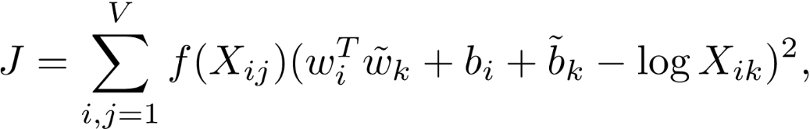Calculate the final Co-occurrence matrix using the cost function [59] [60]:

Figure 7 cost function for the GloVe Co-occurrence matrix

* The matrix can be calculated over many dimensions, creating many vector values that can be calculate to find the distance between two certain words using cosine or Euclidean distance [59] [60].

### Implementation Details:

* Both stemmed and un-stemmed datasets were used to create a word vector models, the stemmed dataset turned out to be more effective as it generalized some terms instead of repeating them (confused, confusion=confus).
* The models were saved as 2D array for vectors in .txt format.
* The text file was loaded into tensorflow projector [61] [62]to represent the points of the model into an intelligible 3D (in truth 100D) plot (pictured above).
* This plot allows the observation of related concepts in a readable manner, each dot representing one of the model’s label. The closer two dots are to each other, the higher their association, and therefore the probability of co-occurrence.

Two approaches were made for the analysis:

1. Discover the relation between ADRs and Drugs.

* After the models were saved into several formats, they were trimmed to only include ADRs and Mental issues, as they are the most relevant for this analysis.
* By looking at the closest vectors to a certain drug, it was possible to find which ADRs and Mental issues have the highest chance to occur when using the drug. For example, amlodipine was found more related to hoarseness, frenzy and hallucinations than it is related to pain, nervousness and alcohol abuse. It is therefore more expected for a patient to encounter hoarseness- for example- than to encounter pain while taking the drug.

1. Discover any related concepts to the drugs and ADRs.

* The models were trimmed to include the words with a relatively high term frequency (above 20, 40, 60, or 100), in order to make it more readable by removing the least used words with little effect on the model.
* The goal is to find any randomly related concepts that might relate to the use of the drug, like for example dosage, age, a certain height or weight. It could therefore be understood from the results if there is any remote relation between the usage of this drug, or the presence of the ADR, and the presence of these other concepts.
* The dataset was slightly modified to attach several concepts to each other to become on term (200 mg = 200mg) which limits the model size and helps make it more accurate and readable.

## Association with Apriori

Association rule mining is extremely important as a data mining technique, it can be help for decision making. And in the context of this project, it can identify the relation between the occurrences of Drugs, Drug Family and all the ADRs, mental issues and diseases.

In association rules, the goal is to identify the following major components [63]:

* Support: Records Containing A/Total Records = the number of times one or more items appear in the records [63].
* Confidence: Confidence (A =>B) = (Records containing both (A and B)) / (Records containing A) = the likelihood that if one item appear in a record, another one also appears [63].

Apriori Algorithm is an application to the association rule mining used to decrease the run time for a large dataset [63] [64]. Generally, the standard algorithm is calculate all the rules for all the dataset. In Apriori however:

* Set a minimum requirement for any component, support as a beginning [63] [64].
* Calculate the support for all 1-itemsets (I1) [63] [64].
* Choose I1 that meet the minimum requirement as candidates (C1), and drop the rest [63] [64].
* Find I2 for C1 and calculate the rest of the components [63] [64].
* Repeat for Ix and C(x-1) until no more candidates are available [63] [64].
* Typically, the biggest length is C3 at I4 sets, in practice a limit to the length can be placed.

### Implementation Details:

Apyori [63] library was used for this implementation on python.

* As input, concepts mentioned were put into a list of lists, each list corresponding to a record of the posts (example: ["Hypothyroidism ", "Hypertensive disease ", "Ulcer "]).
* Each list was extended to include age, gender, drug and drug family, in order to obtain the relation between them (Drug and Drug Family relations were later removed to avoid confusion.
* After running Apriori using Apyori. The result was printed in a .txt file to be reviewed later.

# Supervised Learning

## Preparing the dataset

After building the dictionary, it is now possible to identify the diseases, ADRs, and mental issues that were mentioned in the user posts.

* **Pandas** library was used to access and manipulate the data.
* A scanner was made to iterate on every token in every record in the stemmed version of the dataset, matching each token with an equivalent in the dictionary.
* When a token matches the dictionary, it marks the meaning of the concept as existing if another token with same meaning, such as (‘ache’: ‘pain’, ‘pain’: ‘pain’), it is ignored to limit repetition.
* The number of concepts (diseases, ADRs and mental issues), were counted for each record.
* Two types of classes are created using this process.
  1. Concept exists, where for each concept, a Boolean value is given to determine the existence of the concept in the record.
  2. Concept count, where the number of specific concepts in a particular range is drawn, meaning the number of distinct ADRs in a record for example is 5, this number is recorded and then assorted in the following ranges as a class.
     + 0 for 0 concept.
     + 1 for range [1,3].
     + 2 for anything more than 3.

In the previous example, 5 will be in the 2 class.

1. As for the features, user information harvested is used, such as age, gender, blood pressure, weight and height. Unfortunately, the MedHelp dataset has a lot of missing data, so not all user information could be used at the same time.
2. To solve this issue, the dataset was divided into three groups.
   1. Age + Gender only
   2. Age + Gender + Weight + Height
   3. Age + Gender + Blood Pressure

|  |  |  |  |  |
| --- | --- | --- | --- | --- |
| Dataset Description | MedHelp Complete | Weight/Height | Blood Pressure | Ask A Patient |
| Number of Posts | 1557 Posts | 130 Posts | 462 Posts | 757 Posts |
| Maximum Post size | 12951 Token | 7868 Token | 6829 Token | 1939 Token |
| Minimum Post Size | 8 Token | 254 Token | 174 Token | 3 Token |
| Features | Age, Gender, Drug, Drug Family | Age, Gender, Drug, Drug Family, Weight and Height | Age, Gender, Drug, Drug Family, Blood Pressure | Age, Gender, Drug, Drug Family |

Table 1 Dataset Description

|  |  |  |  |  |
| --- | --- | --- | --- | --- |
| Feature Description | MedHelp Complete | Weight/Height | Blood Pressure | Ask A Patient |
| Age | 12 to 107  Blank=515 | 15 to 79  Blank=10 | 12 to 80  Blank=107 | 15 to 91  Blank=0 |
| Gender | ‘Male’: 581, ‘Female’: 553, Blank: 423, | ‘Male’: 71, ‘Female’: 41, Blank: 18 | ‘Male’: 199, ‘Female’: 167, Blank: 96 | ‘Female’: 423,  ‘Male’: 333 |
| Weight |  | 27 to 172 KG |  |  |
| Blood Pressure |  |  | Max: 295/135  Min: 102/60 |  |

Table 2 Feature Description

* Now that missing data is in an acceptable level, the remaining missing values (Age and Gender) were imputed using the SciKit learn library, SimpleImputer. Gender was imputed based on most frequent strategy, while age was imputed based on median strategy.
* The data sizes for the three datasets respectively is: 1557, 130, 462. With dataset 2 ⊆ dataset 1 and dataset 3 ⊆ dataset 1. Each subset is stored in a separate excel file.
* The classes labels were stored in separate excel files, from which they can be extracted later and used in the classifier.
* The same procedure was applied for AskAPatient dataset, however the dataset did not include anything other than age and gender, therefore as a whole the size of the dataset is 757 with no divided parts between them.
* The dataset can thus be modified to suite any learning model, either by including all the labels (except the class) as a part of the features, or by separating them completely and only using the patient profile and drug/drug family as features.
* Drug/Drug family can also be used as features, where the goal is to find out the possibility by which a drug could cause ADRs and diseases.

## Dataset Imbalance

All the dataset have data label imbalance due to infrequency in the ADRs per each patient, in the complete MedHelp dataset, the highest percentage is “Pain” label, with 76% negative and 24% positive. The subsets are generally more even, but there is still too much imbalance in most labels. The “Hypertensive Disease” label and count labels are however have a better distribution, so they could be used for a more accurate measure of the quality of the dataset.

As for the remaining labels, several techniques could be applied.

1. Oversampling re-use: Several records of the minority class are repeated [65].
2. Under-sampling: Several records from the majority class are unused [65].
3. SMOTE (Synthetic Minority Over-sampling Technique): Where entirely new instances of the records are created to fill the gaps [65].

Approach number 3 was chosen for this application, using the imbalanced-learn implementation [66], using SMOTENC library (NC = Nominal Continuous).

**SMOTE** works as follows [65]:

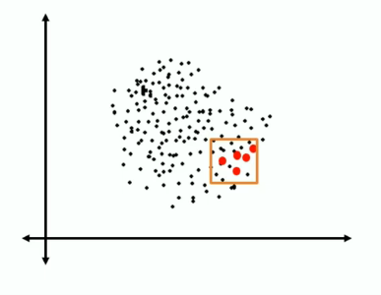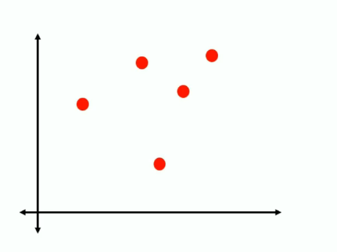1) Isolate the minority class [67]

Figure 8 SMOTE: All Data [67]

Figure 9 SMOTE isolated minority [67]

2) Find the k nearest neighbors depending on the over sampling requirement, calculate the distance between the two neighbors [67].

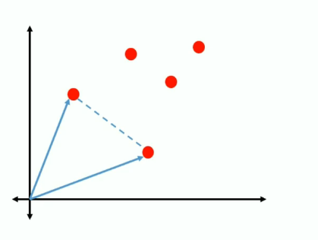

Figure 10 SMOTE KNN [67]

3) Multiply the distance with a random number between 0 and 1, placing a new record of the minority class on the new point created [67].

Figure 11 SMOTE random new record by distance [67]

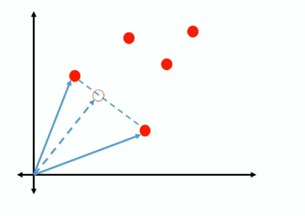4) Repeat until data label imbalance is solved [67].

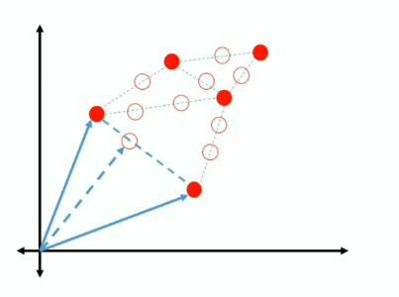

Figure 12 SMOTE new Data [67]

SMOTE however only works with continuous features, which is problematic since most the dataset is nominal/categorical, using either Boolean features or discrete categories that describe drug/drug family and counts.

This is why **SMOTENC** is used instead [65], SMOTENC looks acts the same way as SMOTE, however, between the closest neighbors, the median of the standard deviation of the nominal feature is taken into consideration for the distance [65]. With the distance calculated, continuous values are calculated based on normal SMOTE, while nominal features are given based on the majority of values within those neighbors [65].

SMOTENC implementation works exactly the same as SMOTE, by fitting the dataset to each other using SMOTENC object, only the difference is pointing out which of these features are nominal, SMOTENC is compatible with Pandas Dataframe, with the a list of new features as output to be used in the classifier.

Performance of the classifiers with and without SMOTENC will be compared together.

## Preparing Classifiers

#### Goals:

There are several goals that could be achieved by using classifiers.

1. Predict the possibility for a user to be affected by an ADR or Disease based on extracted profile.
2. Predict which drug or drug family is the cause of the ADRs or Disease affecting the user, with the help of the user profile.
3. Predict the number of ADRs or Diseases that could be caused by a drug, based on the user profile and/or existing cases.

A separate classifier group will be made for each goal, each classifier group using a different dataset arrangement, which will be furthermore elaborated on in the following section.

#### Dataset Arrangements:

Features differ depending on the used subset in terms of user profile.

Table 3 Data arrangements used for the experiments

Arrangement 1 and 3 will include predictions for the Count of ADRs diseases, mental issues count will be ignored as their mentions are very low for in askapatient dataset. However the mentions themselves will be used for as features.

#### The Classifiers

Three classifiers are made as a performance comparison.

1. Random Forests
2. SVM
3. Naïve Bayes
4. **Random Forests (RF)**

Random Forests is an ensemble classifier for classification and regression trees [68] [69].

It works as follows:

Create a certain number of decision trees classier N [69] [70].

Commence bootstrapping operation:

* + Subsets of the original dataset are randomly selected to be used for each tree classifier in N, repetitions are possible.
  + For each subset, choose random features to use instead of using them all [69] [70].

Each resulting tree can be completely different from the others and can give different classification results.

Each one of these results calculated in a vote, with the highest voted result being chosen as the final result for the classification [69] [70].

1. **Random Forests in Scikit Learn**

The random forests implementation is provided is SciKit learn as an ensemble classifier, the main parameter given is “n_estimators”, which is the number of bootstrapped trees that should be constructed. Estimators between 100 and 1000 were tested to ensure accuracy.

1. **Feature Selection**

In addition to the classification capabilities, RFs can be used for embedded feature selection [71], as each time a new tree is made with a subset, a purity metric can be measured, since not all trees see all features, there is an assured de-correlation between all features, this also makes them less prone to overfitting [71]. By calculating the purity of the tree can be used to derive the importance of the features, giving a standard on which feature is more important than the other and thus which feature could be removed [71]. Scikit Learn provides this capability view feature_selection library, which can use an RF classifier to test the data and choose the best features based on an initial classification [71]. This method will be tested on all the classification methods, and observations will be provided for the improved performance if any.

1. **SVM**

First introduced by Vapnik, SVM is a very popular classification and regression technique [72]. It is based on the Structural Risk Minimization principle (SRM) [72], where the classifier maps input vectors to a higher dimensional space where a maximal separating hyperplane is constructed on each side of the hyperplane separating the data [72]. The goal is to maximize the hyperplane, the assumption being that when the bigger distance between two hyperplanes are maximized, the better the generalization error of the classifier [72].

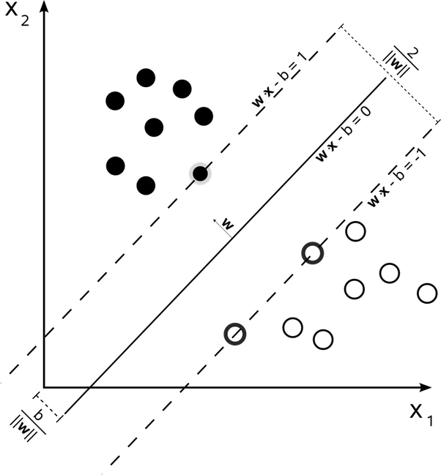The goal is to maximize 2 / | W |

The hyperplane is calculated based on several factors, the most important of which is kernel. Here are the most popular kernels [72]. RBF

* Linear
* Sigmoid
* Polynomial

RBF being the most commonly used for handling higher dimensional space better than Linear, with less parameter than Polynomial, and less numerical difficulties [72].

Figure 13 SVM [77]

SciKit learn implementation provides all these assortment of kernels, as a parameter to the SVM classifier [72], with RBF as default kernel.

1. **Naïve Bayes Classifier**

Naïve Bayes (NB) is one of the simplest probabilistic classifiers available, it is based on Bayes rule [73]. Where P© is the probability of a class (yes or no/Pain exist or doesn’t exist), and P(X) is the probability of all the features. P (C|X) is the probability of the class given all the features used [73]. If the probability of P(C=exist|X) > P(C=not|X), than the classifier predicts that yes, this ADR exists and vice versa [73].



Figure 14 Bayes Rule [73]

NB is reported to be extremely simple as it only relies only on simple mathematics and statistics.

The implementation on SciKit learn is GaussianNB, which uses the Gaussian distribution to represent continuous variables. Although there are other distribution options are available [74]. 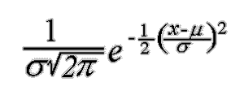Including Bernoulli, Multinomial and Complement.

Figure 15 Gaussian distribution [74]

**Performance Metrics:** The performance of the classification is important to test capabilities of the trained classifier and evaluate the results without having to delve into specific cases [75]. The performance metrics used are based around the concept of the confusion matrix [75].

Each cell identifies the count of test cases that received a given result. True positives and negatives (TP and TN) indicate that the prediction was correct and matching to the actual test data. While false negative and positive (FN and FP) indicate the wrong in predictions. Usually it is better to have FP than FN because a positive can be an alert, while negative means no detection at all [75].

Figure 16 Confusion matrix

Based on the matrix, four metrics were chosen to measure the performance:

1. Accuracy = (TP+TN)/(FP+FN+TN+TP): Correct prediction/all predictions [75], it is good measure when most classes are nearly balanced [75].
2. Precision = TP/(TP+FP): The amount of TP in proportion to all the positives [75].
3. Recall = TP/(TP+FN): The amount of Negatives that were missed [75].
4. F1-Score= 2*Precision*Recall/(Precision + Recall): the harmonic mean of precision and recall, meant to be used as a simplification, instead of having to look into 2 different values, F1-Score gives an approximation that is closer to the smaller number, and thus more accurate and representable number [75].

There are other metrics that could be used, but these are the most standard (as discussed in the literature survey).

1. **Testing Parameters:**

To calculate the performance, the dataset has to be trained using a given set of data, and tested against another set it has never seen. The dataset can be used for that by randomly splitting the data into a testing set and training set, the usual ratio for this purpose is 70% for training and 30% for testing. Values in the confusion matrix can be calculated in the testing part, and from this the metrics can be calculated.

1. **Implementation details**

The implementation was originally meant to be made in python 2.7, and indeed most the text processing made Data retrieval and Dictionary Building was in 2.7. However the initial experiments with GloVe showed that 2.7 was extremely outdated. Therefore the learning process was moved to python 3.6, in which installing was much easier.

Environment: Using python required setting up an environment that could allow the use of all necessary libraries, thus Anaconda was installed, and configured for both 2.7 and 3.7 while each was in use.

This small list of libraries were necessary for the making of this project.

* Pandas: File and Dataset management
* NLTK (PorterStemmer, remove stopwords, tokenize text)
* Sklearn (classifiers, Count Vectorizer, label encoder, feature selection, K-Fold testing, imputer, TFidf Vectorizer)
* Imblearn.SMOTENC
* GloVe

1. **IDE**

Most text processing was made on anaconda’s Spyder IDE, however, while making the classifiers, the implementation was moved to Jupyter Notebook, which was more convenient as it allowed complete code separation and easier document comments.

Jupyter uses separated cells which can be modified and run separately, while still maintaining the same variable and importation pool. This allowed the interfacing between several functions, where each classifier is in a different cell, each run of the classifiers is in a different cell, the dataset manipulation and preparation is independent from running the classifiers.

Therefore whenever any arrangement was tested, the only change needed was to the data manipulation functions with minimal changes to the classifier.

Jupyter does not support concurrency. However for convenience, all cells could run at once in the sequence they were placed.

Cells could be changed from code to headings or simple text, they could be added, moved, stopped and repeated independently from one another.

1. **Classifier Flow**

As shown in this flow chart:

1. The dataset is collected from the excel files.
2. The dataset is modified to suit whichever dataset arrangement in use.
3. Then there are two steps:
   * SMOTENC resampling.
   * Feature Filtering with random forests.
4. Store metrics to be used for comparison between all combinations later on.



Figure 17 Classifier flow

Chapter 4: Results and Discussion

# Unsupervised Algorithm

## GloVe Results

In this section, the results given from applying GloVe to the dataset will be discussed, where the closest terms given will be provided for context. All the experiments were run on a 100 dimensional parameter.

### Drugs and ADR relation

Using the vectors acquired from GloVe, the following results were obtained:

The tensorflow projector [62] allowed displaying the results in a 3D view. By searching for a single word, mainly a drug or an ADR, the words closest to the meaning of the word are highlighted. The tool allows decrease the viewed portions to an intelligible level, this will be limited to 40 words. The distance between the words can be calculated with either Euclidean or cosine distance, which don’t make much difference, therefore Euclidean distance was used, it should be noticed that the words are stemmed.

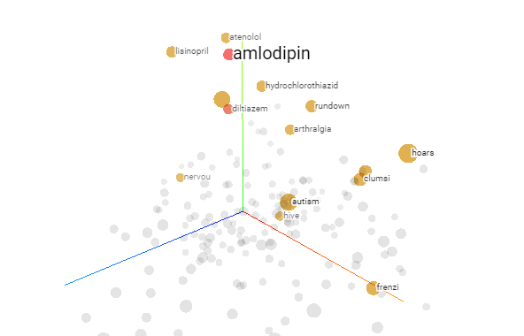

Figure 18 Tensorflow vector projector

#### MedHelp Dataset:

GloVe was able to identify which concept are the drugs, where for all the drugs, the closest concepts are in majority the five other drugs. It also shows the most frequent ADRs that were encountered in the dataset.

Despite Amlodipine and Diltiazem being of the same drug family, they have little ADRs in common, which could suggest that the problem is in the drugs themselves, not in the drug family. Atenolol and Nadolol on the other hand had more in common although in different degrees to the other.

|  |  |  |
| --- | --- | --- |
| Amlodipine | Diltiazem | Hydrochlorothiazide |
|  |  |  |

Table 4 GloVe Result (a)

|  |  |  |
| --- | --- | --- |
| Nadolol | Atenolol | Lisinopril |
|  |  |  |

The Common ADRs that repeat most commonly are:

* Hoarseness
* Apnoea
* Sleeplessness (Insomnia)
* Anxiety
* Doe

Table 5 GloVe Result (b)

#### Ask A Patient Dataset:

This dataset was more focused than MedHelp, and therefore its size was much smaller, especially that only two drugs were tested on it.

Despite this, it not only identified, several common ADRs, but it also identified other drugs that are not within the scope of the dataset search.

|  |  |
| --- | --- |
| Atenolol | Lisinopril |
|  |  |

Table 6 GloVe Result (c)

### Related Concepts Discovery

#### MedHelp Dataset:

The previous section discussed the results of the limiting presented vectors to drugs and ADR. In this section, the vectors presented are limited by their overall frequency, the goal is to discover what kind of general terms accompany drugs, to insure that drugs are mentioned, they are attached to posts before being trained as well as the drug family.

The results show that it was still capable of identifying other drugs, but less effectively, drug family is always the closest, since it is attached to wherever a drug is mentioned, the most common things people appear to mention in their posts is the dosage (x mg), the number of times they take a dose (twice), the duration (daily), and the injection method (pill or tablets), by far the most common word is ‘Hi’, which shows how this medical forum is aimed more towards community rather than a focused drug review website.

|  |  |  |
| --- | --- | --- |
| Amlodipine | Diltiazem | Hydrochlorothiazide |
|  |  |  |

Table 7 GloVe Result (d)

|  |  |  |
| --- | --- | --- |
| Nadolol | Atenolol | Lisinopril |
|  |  |  |

Table 8 GloVe Result (e)

#### Ask A Patient Dataset:

The previous analysis from the dataset is further confirmed, where dosage is even more frequent, however it is more discrete and to the point, with most words written being directly related to drug consumption and related issues to it and indicate more suffering compared to the community friendly MedHelp.

This does not necessarily mean that MedHelp users face any less issues, but it shows that AskAPatient is efficient and compact, with less descriptions given comparing to MedHelp.

This however makes AskAPatient harder for data mining as it contains less user information that users mention while talking about their issues.

|  |  |
| --- | --- |
| Atenolol | Lisinopril |
|  |  |

Table 9 GloVe Result (f)

## Apriori Results

In this section, the results obtained from applying Apriori algorithm to the dataset’s mentioned ADRs, diseases, mental issues, gender of user and drug used, will be discussed. The parameters specified were made as follows:

* Minimum support = 6%, this value was chosen based on the 6% of patients going to hospitals for because of ADRs.
* Minimum confidence = 65%

### MedHelp

Rule: ['Amlodipine'] -> ['Hypertensive disease ']

Support: 0.06767676767676768

Confidence: 0.6836734693877552

=====================================

Rule: ['Pvc'] -> ['Atenolol']

Support: 0.10808080808080808

Confidence: 0.656441717791411

=====================================

Rule: ['Pvc'] -> ['Beta']

Support: 0.11515151515151516

Confidence: 0.6993865030674846

=====================================

Rule: ['Common Cold '] -> ['Upper Respiratory Infections ']

Support: 0.06262626262626263

Confidence: 0.96875

=====================================

Rule: ['Diabetes'] -> ['Hypertensive disease ']

Support: 0.0696969696969697

Confidence: 0.6571428571428571

=====================================

Rule: ['MUNGAN SYNDROME '] -> ['Hypertensive disease ']

Support: 0.15858585858585858

Confidence: 0.6796536796536796

=====================================

Rule: ['MUNGAN SYNDROME ', 'Female'] -> ['Hypertensive disease ']

Support: 0.06161616161616162

Confidence: 0.6630434782608695

### Discussion on MedHelp

It can be noted that the only drugs mentioned within the given parameters are Atenolol and Amlodipine, being a beta-blocker and a calcium channel blocker respectively [76].

Not much information were obtained from MedHelp using Apriori within those constraints, except as a proof of concept, by finding related diseases (['Common Cold '] -> ['Upper Respiratory Infections ']) and disease cured by the mentioned drugs (['Pvc'] -> ['Atenolol'] and ['Amlodipine'] -> ['Hypertensive disease '])

### AskAPatient

Rule: ['MICROCEPHALY , EPILEPSY , AND DIABETES SYNDROME ', 'Coughing'] -> ['Female']

Support: 0.06551059730250482

Confidence: 0.7555555555555555

=====================================

Rule: ['MICROCEPHALY , EPILEPSY , AND DIABETES SYNDROME ', 'Lisinopril'] -> ['Female']

Support: 0.10211946050096339

Confidence: 0.7162162162162162

=====================================

Rule: ['Angiotensin', 'MICROCEPHALY , EPILEPSY , AND DIABETES SYNDROME ', 'Coughing'] -> ['Female']

Support: 0.06358381502890173

Confidence: 0.75

=====================================

Rule: ['MICROCEPHALY , EPILEPSY , AND DIABETES SYNDROME ', 'Lisinopril', 'Coughing'] -> ['Female']

Support: 0.06358381502890173

Confidence: 0.75

=====================================

### Discussion on AskAPatient

Lisinopril is the only drug that appeared in this result with those parameter, AskAPatient was more complete and concise comparing to MedHelp, therefore better detailed patterns about the ADRs, Diseases and drugs appeared.

The most interesting thing however is that all the results include a females as a consequence of the other terms appearing (example: ['Angiotensin', 'MICROCEPHALY , EPILEPSY , AND DIABETES SYNDROME ', 'Coughing'] -> ['Female']), which is strange because only 55% of AskAPatient users are female, which could show that females in general are more in danger of getting a disease, and even more in danger of being inflicted by an ADR after consuming a drug.

### Discussion on Apriori

The results from association rules are usually more respected when used on higher constraints, the given constraints in this case are either too large to find a useful statistical relationship with an acceptable statistical performance.

# Supervised Learning Results:

In this section, various datasets and the arrangements used in them to compare the performance between the prediction capability of the classifiers Random Forests, SVM and Naïve Bayes, the primary point of comparison will be FScore and accuracy, with recall and precision being available to interpret the results from FScore.

The main point of comparison is the performance when SMOTENC and RF filter is applied, and the performance when they are not.

## Legends

|  |  |
| --- | --- |
| **Dataset** | **Meaning** |
| Complete Dataset | The complete original 1577 posts taken from MedHelp, including all the missing data and only having age and gender as user data |
| Weight/Height Dataset | Subset of Complete made of 130 posts which includes Weights/Heights extracted from the posts, some Heights are imputed. |
| Blood Pressure Dataset | Subset of Complete made of 461 posts the include blood pressure readingss |
| AskAPatient | The dataset obtained from AskAPatient, which includes 757 drug reviews. |

Table 10 Legends to describe the Datasets

## Summarized Discussion Supervised Learning

### SMOTENC: Before and After

|  |  |  |  |  |
| --- | --- | --- | --- | --- |
|  | SMOTE | | No Smote | |
|  | Accuracy | Fscore | Accuracy | Fscore |
| Complete Dataset | 0.592814 | 0.59254 | 0.598290598 | 0.59287 |
| Weights/Heights  Dataset | 0.729167 | 0.726196 | 0.820512821 | 0.78419 |
| Blood Perssure Dataset | 0.756098 | 0.756061 | 0.748201439 | 0.699413 |
| AskAPatient Dataset | 0.720548 | 0.71901 | 0.77092511 | 0.514319 |

A comparison between the datasets before and after applying SMOTENC was made in the first experiment. The results provided show that not applying SMOTENC leads to higher accuracy, but had a smaller values for the other more important metrics, namely Recall, Precision and F1-Score (FScore). However for classes where Datasets are already balanced (like Hypertensive disease in Weights/Heights dataset and in the complete dataset) the results may not change much and may even drop when in use, this is why it is not recommended to use SMOTE unless the unbalance is overwhelming.

Table 11 SMOTE VS NO SMOTE Hypertensize Disease

Figure 19 SMOTE VS NO SMOTE Hypertensize Disease

### Random Forests vs SVM vs Naïve Bayes

Throughout the first and second experiments, Random Forests outperformed both SVM and Naïve Bayes, both when using SMOTENC and without, and even when using feature filtering. Therefore it was decided to ignore it on the third experiment if it did not produce a better result, which it did not.

Table 12 RF vs SVM vs Naive Bayes

|  |  |  |  |  |  |  |
| --- | --- | --- | --- | --- | --- | --- |
|  | Random Forests | | SVM | | Naïve Bayes | |
|  | **Accuracy** | **FScore** | **Accuracy** | **FScore** | **Accuracy** | **FScore** |
| Complete Dataset | 0.53405 | 0.532069 | 0.443548 | 0.432164 | 0.305556 | 0.273662 |
| Weights/Heights Dataset | 0.629032 | 0.617931 | 0.387097 | 0.390853 | 0.451613 | 0.414229 |
| Blood Pressure Dataset | 0.620072 | 0.616403 | 0.512545 | 0.510708 | 0.365591 | 0.333318 |
| AskAPatient | 0.802139 | 0.802116 | 0.754011 | 0.752994 | 0.721925 | 0.714067 |

Figure 20 RF vs SVM vs Naive Bayes

### Feature Filtering

Feature filtering using random forests in general produced varying results, both positive and negative in all metrics, but generally there was definitive improvement over not using it. However it did reveal a strange result, where after reviewing the second experiment, it turns out that the count of diseases, and mental issues were a major factor in improving the results in some cases, and that it was chosen as the most important besides user age.

Table 13 Filetring vs No Filtering

|  |  |  |  |  |
| --- | --- | --- | --- | --- |
|  | With Filtering | | Without Filtering | |
|  | **Accuracy** | **FScore** | **Accuracy** | **FScore** |
| Complete Dataset | 0.335125 | 0.333261 | 0.53405 | 0.532069 |
| Weighted/Height Dataset | 0.66129 | 0.648689 | 0.629032 | 0.617931 |
| Blood Pressure Dataset | 0.594982 | 0.585986 | 0.620072 | 0.616403 |
| AskAPatient | 0.828877 | 0.827277 | 0.802139 | 0.802116 |

Figure 21 Filtering vs No Filtering

### Predicting the potential number of ADRs and Diseases per user

|  |  |  |
| --- | --- | --- |
| **Number Of ADRs** | **Accuracy** | **FScore** |
| Complete Dataset | 0.448882 | 0.449865 |
| Weighted/Height Dataset | 0.454545 | 0.455265 |
| Blood Pressure Dataset | 0.594203 | 0.594168 |
| AskAPatient | 0.574324 | 0.577359 |
|  |  |  |
| **Number Of diseases** | **Accuracy** | **FScore** |
| Complete Dataset | 0.494253 | 0.482369 |
| Weighted/Height Dataset | 0.655172 | 0.651343 |
| Blood Pressure Dataset | 0.713675 | 0.703807 |
| AskAPatient | 0.564033 | 0.572111 |

Feature filtering did not choose ADR count as important, and after trying to find it in the first experiment the results were not satisfactory. On the other hand, trying to find the amount of diseases was more fruitful, for blood pressure and weights/heights datasets, which show how important they are in determining the potential healthiness of a person, but in any case, the results from the other classifiers make it discouraging to make such prediction.

Table 14 Number of Diseases and ADRs

Figure 22 Number of Diseases and ADRs

### Discovering ADRs and Diseases

The first and third experiments tried to predict the presence of the ADRs and diseases based on user profile, at 66% F-Score for Pain in MedHelp, the first experiment was successful with good results, however when using medical history from other ADRs and disease mentions in the third, this result has improved by more than 10%.

|  |  |  |
| --- | --- | --- |
| **With Medical History** | **Accuracy** | **FScore** |
| Complete Dataset | 0.828816 | 0.828562 |
| Weighted/Height Dataset | 0.925926 | 0.922078 |
| Blood Pressure Dataset | 0.880597 | 0.880357 |
| AskAPatient | 0.79661 | 0.79661 |
| **Without Medical History** | **Accuracy** | **FScore** |
| Complete Dataset | 0.666191 | 0.664272 |
| Weighted/Height Dataset | 0.796296 | 0.794535 |
| Blood Pressure Dataset | 0.746269 | 0.745361 |
| AskAPatient | 0.714689 | 0.708642 |

Table 15 Pain Prediction with and without medical history

Figure 23 Pain predictions with and without medical history

### Predicting the presence of any possible ADR

As a comparison with some related work, this prediction was made, the goal is to find if it is possible to predict if the user got afflicted by any ADR, no specifics given other than the presence, this has proven to be successful and comparable with some results given in some of the papers on supervised learning, more specifically the result in figure 2 and figure 3, even the results without applying SMOTE were satisfactory, and they show the potential of user profile and medical history as features.

|  |  |  |
| --- | --- | --- |
| **No Smote** | **Accuracy** | **FScore** |
| Complete Dataset | 0.788462 | 0.772765 |
| Weighted/Height Dataset | 0.666667 | 0.547725 |
| Blood Pressure Dataset | 0.863309 | 0.82936 |
| AskAPatient | 0.823789 | 0.778104 |
| **Smote** | **Accuracy** | **FScore** |
| Complete Dataset | 0.843072 | 0.842752 |
| Weighted/Height Dataset | 0.892857 | 0.892308 |
| Blood Pressure Dataset | 0.85641 | 0.856406 |
| AskAPatient | 0.89645 | 0.89588 |

Table 16 ADR prediction

Figure 24 ADR prediction

## First Experiment

* The most common ADR (Pain) as labels.
* The most common disease (Hypertensive Disease) as labels.
* Counts for ADRs, diseases and mental issues as labels.
* Testing the best number of estimators in terms of F-Score for random forests was made by trying all estimators between 100 and 1000 at 100 increment.

Table 17 Feature Description

|  |  |  |  |  |
| --- | --- | --- | --- | --- |
| **Labels/Datasets** | Hypertensive Disease | Pain | ADRCount | DiseaseCount |
| Complete Dataset | 0: 834, 1: 723 | 0: 1168, 1: 389 | 1: 695, 0: 560, 2: 302 | 1: 870, 2: 489, 0: 198 |
| Weight/Height Dataset | 1: 80, 0: 50 | 0: 89, 1: 41 | 2: 48, 1: 45, 0: 37 | 2: 64, 1: 58, 0: 8 |
| Blood Pressure Dataset | 1: 273, 0: 188 | 0: 334, 1: 127 | 1: 229, 0: 137, 2: 95 | 1: 259, 2: 155, 0: 47 |
| AskAPatient | 0: 608, 1: 148 | 0: 590, 1: 166 | 1: 493, 0: 194, 2: 69 | 1: 407, 0: 324, 2: 25 |

### Random Forests

#### SMOTENC versus without SMOTENC

##### Hypertensive diseases Predictons:

* Hyper Tension successfully predicted with blood pressure, with weights/heights being second. This gives importance to both readings as they can predict certain diseases.
* On trials without SMOTENC, the roles were reversed, weights/heights performance increasing much higher than blood pressure, this indicates that the unmodified pressure subset is inefficient compared to weights.
* While Ask a patient’s performance fell, MedHelp complete dataset had remained stable, which is a direct result from the imbalance in ask a patient compared to MedHelp. The results however are a good indication that Hypertension can be predicted with a decent accuracy based on age alone, with other factors such as weight and height aiding the predictions.

|  |  |  |  |  |
| --- | --- | --- | --- | --- |
| **Datasets** | **Accuracy** | **Precision** | **Recall** | **FScore** |
| Complete Dataset | 0.592814 | 0.593139 | 0.592869 | 0.59254 |
| Weights/Heights Dataset | 0.729167 | 0.739564 | 0.729167 | 0.726196 |
| Blood Pressure Dataset | 0.756098 | 0.756061 | 0.756061 | 0.756061 |
| AskAPatient | 0.720548 | 0.718645 | 0.720076 | 0.71901 |

Table 18 RF Hypertensive disease with SMOTENC

Table 19 RF Hypertensive disease without SMOTENC

|  |  |  |  |  |
| --- | --- | --- | --- | --- |
| **Datasets** | **Accuracy** | **Precision** | **Recall** | **FScore** |
| Complete Dataset | 0.598291 | 0.599863 | 0.595724 | 0.59287 |
| Weights/Heights Dataset | 0.820513 | 0.777778 | 0.792208 | 0.78419 |
| Blood Pressure Dataset | 0.748201 | 0.727473 | 0.68956 | 0.699413 |
| AskAPatient | 0.770925 | 0.520792 | 0.514936 | 0.514319 |

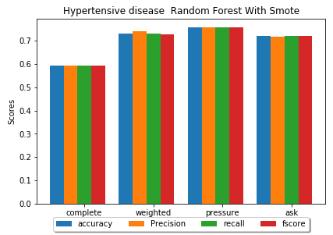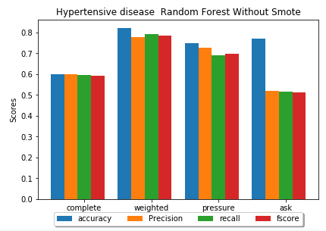

Figure 25 Hypertensive Disease RF With SMOTE

Figure 26 Hypertensive Disease RF Without SMOTE

##### Pain Predictions:

* For pain, weights/heights have the biggest effect, which could indicate that pain as an ADR is cause by weights gain in relation to height.
* On trials without SMOTENC however, all metrics drops far below the accuracy, which reflects the terrible imbalance in all the datasets, despite the fact that it is the most mentioned ADR at 25 % positives to 75% negatives in MedHelp Complete dataset.

|  |  |  |  |  |
| --- | --- | --- | --- | --- |
| **Datasets** | **Accuracy** | **Precision** | **Recall** | **FScore** |
| Complete Dataset | 0.666191 | 0.665535 | 0.664104 | 0.664272 |
| Weights/Heights Dataset | 0.796296 | 0.807586 | 0.827941 | 0.794535 |
| Blood Pressure Dataset | 0.746269 | 0.745526 | 0.745233 | 0.745361 |
| AskAPatient | 0.714689 | 0.718844 | 0.708472 | 0.708642 |

* Ask a patient has suffered the most, with a drop from 0.7 Fscore to 0.47.

Table 20 Pain with SMOTENC

|  |  |  |  |  |
| --- | --- | --- | --- | --- |
| **Datasets** | **Accuracy** | **Precision** | **Recall** | **FScore** |
| Complete Dataset | 0.709402 | 0.552477 | 0.536667 | 0.536188 |
| Weights/Heights Dataset | 0.717949 | 0.621429 | 0.555195 | 0.546032 |
| Blood Pressure Dataset | 0.733813 | 0.690711 | 0.652751 | 0.6622 |
| AskAPatient | 0.696035 | 0.473708 | 0.483679 | 0.471291 |

*Table 21 RF Pain without SMOTENC*

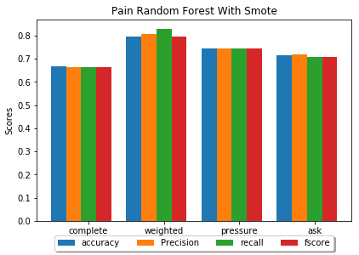

Figure 27 RF Pain with SMOTENC

##### Number of ADRs/ Diseases per user predictions:

* It can be observed that the number of ADRs that a person might have is much harder to predict compared to the number of disease.
* Weights/Heights are terrible for identifying ADR Count, however it performs slightly better for disease count without SMOTENC. Blood pressure decreased the least for ADR count, which could indicate the role it plays in causing ADRs in general.
* It is unclear whether the reason for the terrible performance is due to data imbalance solved by SMOTENC, or that it is naturally impossible to discover ADR and disease Counts based only on these factors.

|  |  |  |  |  |
| --- | --- | --- | --- | --- |
| **Datasets** | **Accuracy** | **Precision** | **Recall** | **FScore** |
| Complete Dataset | 0.448882 | 0.455145 | 0.448323 | 0.449865 |
| Weights/Heights Dataset | 0.454545 | 0.50864 | 0.452381 | 0.455265 |
| Blood Pressure Dataset | 0.594203 | 0.597802 | 0.592951 | 0.594168 |
| AskAPatient | 0.574324 | 0.587815 | 0.574266 | 0.577359 |

Table 22 RF ADR Count with SMOTENC

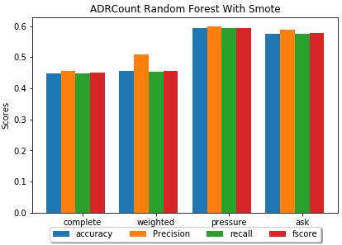

Figure 28 RF ADR Count with SMOTENC

Table 23 RF Disease Count with SMOTENC

|  |  |  |  |  |
| --- | --- | --- | --- | --- |
| **Datasets** | **Accuracy** | **Precision** | **Recall** | **FScore** |
| Complete Dataset | 0.494253 | 0.489404 | 0.488716 | 0.482369 |
| Weights/Heights Dataset | 0.655172 | 0.657018 | 0.649832 | 0.651343 |
| Blood Pressure Dataset | 0.713675 | 0.715905 | 0.71548 | 0.703807 |
| AskAPatient | 0.564033 | 0.587314 | 0.565223 | 0.572111 |

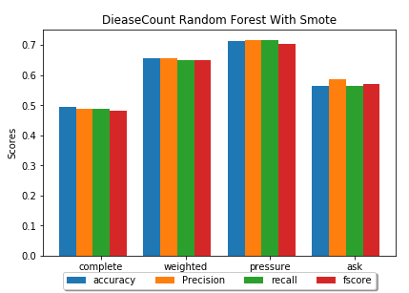

Figure 29 RF Disease Count with SMOTENC

#### Feature Filtering versus Without Feature Filtering

In this section, the comparison between the previous results before and after applying random forests filtering was applied, the conclusion is that it has very little effect on the results for this experiment, this can be attributed to the use of the very limited features. This point will be further tested with experiments 2 and 3, when all the remaining labels will be used as features. The following are some example that show how filtering performed with and without SMOTENC.

##### Hypertensive Disease Prediction

Ask a patient dataset and blood pressure subset have slightly improved their performance. The complete dataset and weight/height subset have decreased their performance slightly, but not far off from the original none filtered features.

Table 24 Hypertensive Disease RF with Feature Filtering and with SMOTENC

|  |  |  |  |  |
| --- | --- | --- | --- | --- |
| **Dataset** | **Accuracy** | **Precision** | **Recall** | **FScore** |
| Complete Dataset | 0.58483 | 0.590532 | 0.585076 | 0.578583 |
| Weights/Heights Dataset | 0.708333 | 0.708333 | 0.708333 | 0.708333 |
| Blood Pressure Dataset | 0.79878 | 0.802252 | 0.79942 | 0.798413 |
| AskAPatient | 0.734247 | 0.740344 | 0.7225 | 0.724099 |

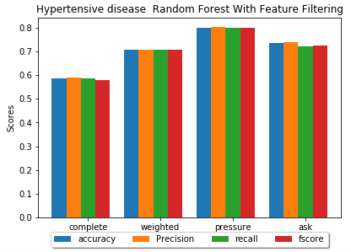

Figure 30 Hypertensive disease RF with Feature Filtering and SMOTENC

### SVM

##### Pain Prediction

* SVM again showed much less performance compared to random forests, and again showing a drop without SMOTENC.
* It should be noted however that while the FScore decreased, the Accuracy is actually higher than RF. Which could mean that SVM could predict unbalanced data more accurately compared to RF, even if the overall performance is lacking.

|  |  |  |  |  |
| --- | --- | --- | --- | --- |
| **Dataset** | **Accuracy** | **Precision** | **Recall** | **FScore** |
| Complete Dataset | 0.64194 | 0.643159 | 0.643231 | 0.641937 |
| Weights/Heights Dataset | 0.555556 | 0.684524 | 0.636765 | 0.545582 |
| Blood Pressure Dataset | 0.711443 | 0.750337 | 0.7215 | 0.705308 |
| AskAPatient | 0.629944 | 0.634494 | 0.63362 | 0.629799 |

*Table 25 Pain SVM with SMOTENC*

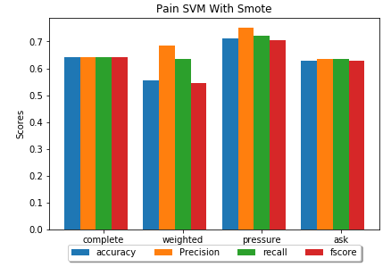

Figure 31 Pain SVM with SMOTENC

### Naïve Bayes

##### Pain Prediction

* The results here have shown a slight improvement over SVM in pressure results, otherwise all other results are mediocre.

*Table 26 Pain NB*

|  |  |  |  |  |
| --- | --- | --- | --- | --- |
| **Dataset** | **Accuracy** | **Precision** | **Recall** | **FScore** |
| Complete Dataset | 0.553495 | 0.553395 | 0.553513 | 0.5532 |
| Weights/Heights Dataset | 0.703704 | 0.720833 | 0.733824 | 0.702069 |
| Blood Pressure Dataset | 0.626866 | 0.626733 | 0.62711 | 0.626533 |
| AskAPatient | 0.5 | 0.535696 | 0.520443 | 0.451768 |

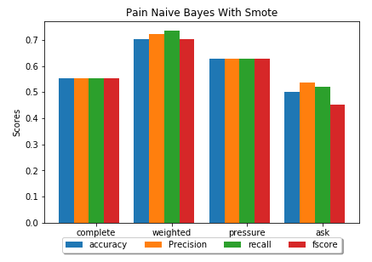

Figure 32 Pain NB

## Second Experiment

* Predict the drug used based on the user profile and user history.
* Predict the drug family based on the user profile and user history.
* The user history is represented by ADR mention features.
* Testing the best number of estimators in terms of F-Score for random forests was made by trying all estimators between 100 and 1000 at 100 increment.

|  |  |  |
| --- | --- | --- |
| **Labels/Datasets** | Drugs | Drug Family |
| Complete | 'Atenolol': 620,  'Lisinopril': 428,  'Amlodipine': 161, 'Hydrochlorothiazide': 129, 'Nadolol': 119,  'Diltiazem': 100 | 'Beta': 739,  'Angiotensin': 428,  'Calcium': 261,  'Diuretics': 129 |
| Weight/Height | 'Lisinopril': 51,  'Atenolol': 45,  'Amlodipine': 14, 'Hydrochlorothiazide': 13 | 'Angiotensin': 51,  'Beta': 45,  'Calcium': 14,  'Diuretics': 13 |
| Blood Pressure | 'Atenolol': 186,  'Lisinopril': 134,  'Amlodipine': 63, 'Hydrochlorothiazide': 51, 'Diltiazem': 26 | 'Beta': 186,  'Angiotensin': 134,  'Calcium': 89,  'Diuretics': 51 |
| Ask A Patient | 'Lisinopril': 622,  'Atenolol': 134 | Angiotensin': 622,  'Beta': 134 |

Table 27 Dataset description 2

##### Drug Prediction

* AskAPatient had the highest result, which reflects its accuracy regarding ADR, disease and mental issues detection, since the mentions are clearer and easy to find, therefore accurately finding the user history is much easier than the rest.
* Weights/Highest and blood pressure are very close in results, both of which have better predictions than the complete dataset, which shows how much role these two information play in the predictions. Which might indicate that high blood pressure, extremely light or heavy weight, might cause diseases that lead to the use of drugs that in turn cause ADRs for using the drug with such extreme
* It should also be noted that AskAPatient is only limited to two drugs, which might explain its high results, as it is easier to identify than the rest.

|  |  |  |  |  |
| --- | --- | --- | --- | --- |
| **Dataset** | **Accuracy** | **Precision** | **Recall** | **FScore** |
| Complete Dataset | 0.53405 | 0.530371 | 0.535376 | 0.532069 |
| Weights/Heights Dataset | 0.629032 | 0.614183 | 0.629097 | 0.617931 |
| Blood Pressure Dataset | 0.620072 | 0.614306 | 0.624035 | 0.616403 |
| AskAPatient | 0.802139 | 0.803151 | 0.802735 | 0.802116 |

*Table 28 Drug Prediction Random Forests*

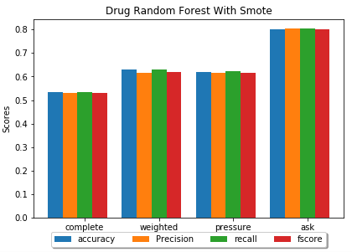

Figure 33 Drug Predictions Random Forests

##### Drug Family Predictions

* AskAPatient resutls did not change at all due to both drugs being from only two drug families, meaning that the exact same classification is made, just under different name.
* The Complete MedHelp dataset had better performance identifying the drug family, mainly because the number of distinct labels have decreased to a more manageable four classes instead of 6.
* As for the decrease in weights/heights and pressure performance, there is no clear explanation for weights/heights since the same conditions as AskAPatient apply here, pressure on the other hand could be explained by possible difference of the two calcium-blockers have in common and their different uses, which results in poorer results when their drug family is identified.

|  |  |  |  |  |
| --- | --- | --- | --- | --- |
| **Dataset** | **Accuracy** | **Precision** | **Recall** | **FScore** |
| Complete Dataset | 0.572717 | 0.573601 | 0.574943 | 0.569366 |
| Weights/Heights Dataset | 0.596774 | 0.593651 | 0.599063 | 0.596121 |
| Blood Pressure Dataset | 0.544643 | 0.559338 | 0.550519 | 0.545089 |
| AskAPatient | 0.802139 | 0.803151 | 0.802735 | 0.802116 |

Table 29 Drug Family Prediction Random Forest

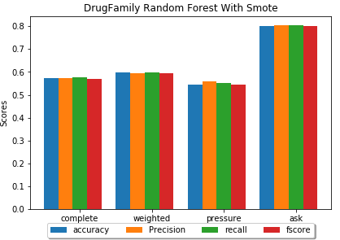

Figure 34 Drug Family Prediction Random Forest

## Third Experiment

* This experiment compares the result between the first experiment’s limit on using user profile data only, and now using all other user history data in addition to the profile. The chosen labels are a part of the history, which are removed when the experiment runs.
* Pain will be used as the main label for this experiment, since it is the most common ADR, having the same values as the first experiment.

**Results:**

*Table 30 Pain prediction random forests*

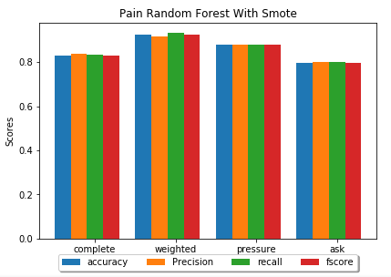 The usage of user medical history has proven to be a success, being able to predict the appearance of pain with more than 10% better

Figure 35 Pain prediction random forests

|  |  |  |  |  |
| --- | --- | --- | --- | --- |
| **Dataset** | **Accuracy** | **Precision** | **Recall** | **FScore** |
| Complete Dataset | 0.828816 | 0.836927 | 0.832474 | 0.828562 |
| Weights/Heights Dataset | 0.925926 | 0.916193 | 0.930882 | 0.922078 |
| Blood Pressure Dataset | 0.880597 | 0.880785 | 0.880105 | 0.880357 |
| AskAPatient | 0.79661 | 0.799699 | 0.799699 | 0.79661 |

Chapter 5: Conclusion

# Conclusion

* A web crawler successfully extracted a wide dataset from specialized medical forums.
* The dataset acquired successfully tested the capabilities of GloVe to find related concepts that, which helped in identifying the most frequent ADR in relation to a drug.
* Sliding window pattern detection was used to extract the user profile data- mainly age, gender, weight, height and blood pressure- to be used as features for various machine learning algorithms.
* A dictionary following the UMLS definitions was built using text with the help of MetaMap, and parsing its output allowed easy translation from plain text to python dictionary, the UMLS concepts- ADRs, diseases and mental issues- were used as features and classes for the supervised learning algorithm.
* Association rule mining using Apriori was tested to find any relationship between drug, drug family, gender of user, diseases and ADRs. It failed in acquiring any useful information within the tight constraints placed, however it was successful as a proof of concept.
* A comparison between the datasets before and after applying SMOTENC was made in the first experiment. The results provided show that not applying SMOTENC leads to higher accuracy, but had a smaller values for the other more important metrics, namely Recall, Precision and F1-Score (FScore).
* Random Forests outperformed both SVM and Naïve Bayes, both when using SMOTENC and without, and even when using feature filtering, therefore it was decided to ignore it on the third experiment if it did not produce a better result, which it did not.
* Feature filtering using random forests in general produced varying results, both positive and negative in all metrics, but generally there was not a definitive improvement over not using it. While reviewing the second experiment, it appears that the count of diseases, and mental issues were a major factor in improving the results in some cases, and that it was chosen as the most important besides user age.
* Feature filtering did not choose ADR count as important, and after trying to find it in the first experiment the results were extremely terrible in most the performance metrics, the same results were found in disease and mental issues count.
* The first and third experiments tried to predict the presence of the ADRs and diseases based on user profile, at 66% F-Score for Pain in MedHelp, the first experiment was successful with good results, however when using medical history from other ADRs and disease mentions in the third, this result has improved to 82% .
* As a comparison with some related work, this prediction was made to predict if the user got afflicted by any ADR, no specifics given other than the presence, this has proven to be successful and comparable with some results given in some of the papers on supervised learning, more specifically the result in figure 2 and figure 3, even the results without applying SMOTE were satisfactory, and they show the potential of user profile and medical history as features, given that more bigger and more diverse dataset is provided.

# Future Work

* A bigger and wider range dataset, with more specialized UMLS concepts and a wider range of drugs, could be used for more advanced pharmacovigilance techniques.
* The crawler designed with JSoup could be modified to extract other data from various medical forums to provided easier access to data for medical research.
* The use of user profile as indication for medical problems could be further developed for a recommendation system, where any person with a certain medical history and have certain attributes could be recommended the use of certain drug that is not known to produce any severe ADRs for such attributes and history.

# References

|  |  |
| --- | --- |
| [1] | R. Edwards and F. K. Aronson, "Adverse Drug Reactions: Definitions, Diagnosis and Management," *Lancet,* vol. 356, no. Number 9237, pp. 1255-1259, 7 October 2000. |
| [2] | World Health Organization, "The Importance of Pharmacovigilance-Safety Monitoring of Medicinal Products," 2002. [Online]. Available: http://apps.who.int/medicinedocs/en/d/Js4893e/1.html. [Accessed 18 11 2018]. |
| [3] | A. Nikfrajam, K. Oconnor, A. Sarker, R. Ginn, S. Jayaraman, T. Upadhya and G. Gonzalez, "Utilizing social media data for pharmacovigilance: A review," *Research Gate,* vol. 54, pp. 202-212, 2015. |
| [4] | US Food & Drug Administration (FDA), "Preventable Adverse Drug Reactions: A Focus on Drug Interactions," US Food & Drug Administration (FDA), 6 3 2018. [Online]. Available: https://www.fda.gov/drugs/developmentapprovalprocess/developmentresources/druginteractionslabeling/ucm110632.htm. [Accessed 19 11 2018]. |
| [5] | R. Leaman, L. Wojtulewicz, R. Sullivan, A. Shariah, J. Yang and G. Gonzalez, "Towards Internet-Age Pharmacovigilance: Extracting Adverse Drug," in *Proceedings of the 2010 workshop On biomedical Natural Language Processing*, Uppsala, Sweden , 2010. |
| [6] | A. Nikfarjam and G. H. Gonzalez, "Pattern Mining for Extraction of mentions of Adverse Drug Reactions From User Comments," *AMIA Annual Symposium Proceedings Archive,* vol. 2011, pp. 1019-1026, 2011. |
| [7] | D. Pappel, "Up To 90 Percent Of Adverse Reactions Unreported, Pharma Companies Search Social Media To Make Drugs Safer," Inquisitr, 14 3 2015. [Online]. Available: https://www.inquisitr.com/1914900/up-to-90-percent-of-adverse-reactions-unreported-pharma-companies-search-social-media-to-make-drugs-safer/. [Accessed 19 11 2018]. |
| [8] | R. Sloane, O. Osanlou, D. Lewis, D. Bollegala, S. Maskell and M. Pirmohamed, "Social media and pharmacovigilance: A review of the opportunities and challenges," *British Journal of Clinicla Pharmacology,* vol. 80, no. 4, pp. 910-920, 2015. |
| [9] | C. C. Yang and H. Yang, "Exploiting Social Media With Tensor Decomposition For Pharmacovigilance," in *2015 IEEE 15th International Conference on Data Mining Workshops*, Atlantic City New Jersey, 2015. |
| [10] | J. Hadzi-Puric and J. Grumsa, "Automatic Drug Adverse Reaction Discovery From Parenting websites using disproportionality methods," in *IEEE/ACM International Conference on Advances in Social Networks Analysis and Mining*, Istanbul, 2012. |
| [11] | A. Sarker and G. Graciela, "Portable Automatic Text Classification for Adverse Drug Reaction Detection Via Multi-Corpus Training," *Journal of biomedical informatics,* vol. 53, pp. 196-207, 2014. |
| [12] | J. Bian, U. Topaloglu and F. Yu, "Towards Large-Scale Twitter Mining For Drug-Related Adverse Events," in *Proceedings of the 2012 ACM International Workshop on Smart Health and Wellbeing*, Hawaii, 2012. |
| [13] | Y. Zheng and K. Jiang, "Mining Twitter Data for Potential Drug Effects," in *Advanced Data Mining and Applications*, Hangzhou, Springer, 2013, pp. 434-443. |
| [14] | A. Nikfarjam, A. Sarker, K. OConnor, R. Ginn and G. Gonzalez, "Pharmacovigilance from social media: mining adverse drug reaction mentions using sequence labeling with word embedding cluster features," *J Am Med Inform Assoc,* vol. 22, no. 3, pp. 671-681, 2015. |
| [15] | H. Sampathkumar, B. Luo and X. W. Chen, "Mining Adverse Drug Reactions from online healthcare forums using Hidden Markov Model," *BMC Medical informatics and Decision Making,* vol. 14, no. 91, 2014. |
| [16] | M. Yang, X. Wang and M. Kiang, "IDENTIFICATION OF CONSUMER ADVERSE DRUG REACTION MESSAGES ON SOCIAL MEDIA," in *PACIS 2013*, 2013. |
| [17] | J. Brownlee, "Classification Accuracy is Not Enough: More Performance Measures You Can Use," Machine Learning Mastery, 21 3 2014. [Online]. Available: https://machinelearningmastery.com/classification-accuracy-is-not-enough-more-performance-measures-you-can-use/. [Accessed 25 11 2018]. |
| [18] | Google, "Classification: Precision and Recall," Google, 1 10 2018. [Online]. Available: https://developers.google.com/machine-learning/crash-course/classification/precision-and-recall. [Accessed 25 11 2018]. |
| [19] | W. Koehrsen, "Beyond Accuracy: Precision and Recall," Towards Data Science, 3 3 2018. [Online]. Available: https://towardsdatascience.com/beyond-accuracy-precision-and-recall-3da06bea9f6c. [Accessed 25 11 2018]. |
| [20] | US Food & Drug Administration (FDA), "Questions and Answers on FDA's Adverse Event Reporting System (FAERS)," US Food & Drug Administration (FDA), 4 6 2018. [Online]. Available: https://www.fda.gov/Drugs/GuidanceComplianceRegulatoryInformation/Surveillance/AdverseDrugEffects/. [Accessed 20 11 2018]. |
| [21] | US Food & Drug Administration (FDA), "MedWatch: The FDA Safety Information and Adverse Event Reporting Program," US Food & Drug Administration (FDA), 14 11 2018. [Online]. Available: https://www.fda.gov/Safety/MedWatch/default.htm. [Accessed 20 11 2018]. |
| [22] | S. Fox, "The Social Life of Health Information," 12 5 2011. [Online]. Available: http://www.pewinternet.org/2011/05/12/the-social-life-of-health-information-2011/. [Accessed 20 11 2018]. |
| [23] | S. Vilar, C. Friedman and G. Hripcsak, "Detection of drug–drug interactions through data mining studies using clinical sources, scientific literature and social media," *Briefings in Bioinformatics,* vol. 19, no. 5, p. 863–877, 28 9 2018. |
| [24] | Arizona State University, "TWITTER ANNOTATED CORPUS," Arizona State University, 2014. [Online]. Available: http://diego.asu.edu/downloads/twitter_annotated_corpus/. [Accessed 20 11 2018]. |
| [25] | DailyStrength, "DailyStrength: Getting Better Together," DailyStrength, 2006. [Online]. Available: https://www.dailystrength.org/. [Accessed 20 11 2018]. |
| [26] | MedHelp, "MedHelp: Be your healthiest," MedHelp, [Online]. Available: https://www.medhelp.org/. [Accessed 20 11 2018]. |
| [27] | PatientsLikeMe, "PatientsLikeMe: Living better starts here.," PatientsLikeMe, 2005. [Online]. Available: https://www.patientslikeme.com/. [Accessed 20 11 2018]. |
| [28] | Medications.com, "The Premier Community to talk about Health," [Online]. Available: http://www.medications.com/. [Accessed 2 12 2018]. |
| [29] | Ask A patient, "When you need to know if a medication really works, why not Ask a Patient?," [Online]. Available: https://www.askapatient.com/. [Accessed 2 12 2018]. |
| [30] | E. K. Ikonomakis, T. V. and K. Sotiris, "Text Classification Using Machine Learning," *WSEAS Transactions on Computers,* vol. 4, no. 8, pp. 966-974, 2005. |
| [31] | U.S. National Library of Medicine, "Metathesaurus," U.S. National Library of Medicine, 12 4 2016. [Online]. Available: https://www.nlm.nih.gov/research/umls/knowledge_sources/metathesaurus/. [Accessed 28 11 2018]. |
| [32] | SiderEffects, "SIDER 4.1 : Side Effect Resource," SiderEffects, 21 10 2015. [Online]. Available: http://sideeffects.embl.de/. [Accessed 28 11 2018]. |
| [33] | Government of Canadian, "MedEffect Canada," Government of Canadian, 26 11 2018. [Online]. Available: https://www.canada.ca/en/health-canada/services/drugs-health-products/medeffect-canada.html. [Accessed 28 11 2018]. |
| [34] | Tartarus, "Snowball," Tartarus, 2 2002. [Online]. Available: http://snowball.tartarus.org/. [Accessed 28 11 2018]. |
| [35] | Rosettacode, "Jaro distance," Rosettacode, 29 7 2018. [Online]. Available: https://rosettacode.org/wiki/Jaro_distance. [Accessed 28 11 2018]. |
| [36] | B. Liu, W. Hsu and Y. Ma, "Integrating Classification and Association Rule Mining," in *The Fourth International Conference on Knowledge Discovery and Data Mining.*, New York, 1998. |
| [37] | The Stanford NLP Group, "Software > Stanford Log-linear Part-Of-Speech Tagger," The Stanford NLP Group, 16 10 2018. [Online]. Available: https://nlp.stanford.edu/software/tagger.shtml. [Accessed 28 11 2018]. |
| [38] | Princeton University, "WordNet A Lexical Database for English," Princeton University, 2018. [Online]. Available: https://wordnet.princeton.edu/. [Accessed 2018]. |
| [39] | Christian Borgelt's Web Pages, "Apriori - Association Rule Induction / Frequent Item Set Mining," Christian Borgelt's Web Pages, 18 10 2018. [Online]. Available: http://www.borgelt.net/apriori.html. [Accessed 28 11 2018]. |
| [40] | A. C. Egberts, R. H. Meyboom and E. P. van Puijenbroek, "Use of Measures of Disproportionality in Pharmacovigilance," *Spriner Link,* vol. 25, no. 6, pp. 453-458, 2002. |
| [41] | Serbian Government, "Medecines and Medical Devices Agency of Serbia," Serbian Government, [Online]. Available: https://www.alims.gov.rs/eng/. [Accessed 2 12 2018]. |
| [42] | DrugBank, "The DrugBank database is a unique bioinformatics and cheminformatics resource that combines detailed drug data with comprehensive drug target information.," DrugBank, [Online]. Available: https://www.drugbank.ca/. [Accessed 2 12 2018]. |
| [43] | USA government, "MetaMap - A Tool For Recognizing UMLS Concepts in Text," USA government, 23 1 2018. [Online]. Available: https://metamap.nlm.nih.gov/. [Accessed 29 11 2018]. |
| [44] | B. W. Chee, R. Berlin and B. Schatz, "Predicting Adverse Drug Events from Personal Health Messages," in *AMIA Annual Symposium Proceedings Archive*, Washington DC, 2011. |
| [45] | MedDRA, "Welcome to MedDRA," MedDRA, [Online]. Available: https://www.meddra.org/. [Accessed 1 12 2018]. |
| [46] | Brandeis University, "Inter Annotator Agreement," Word Press, 28 2 2017. [Online]. Available: https://corpuslinguisticmethods.wordpress.com/2014/01/15/what-is-inter-annotator-agreement/. [Accessed 29 11 2018]. |
| [47] | Sphinx, "Natural Language Toolkit," Sphinx, 17 11 2018. [Online]. Available: http://www.nltk.org/. [Accessed 29 11 2018]. |
| [48] | Carnegie Mellon, "Tweet NLP," Carnegie Mellon, [Online]. Available: http://www.cs.cmu.edu/~ark/TweetNLP/. [Accessed 29 11 2018]. |
| [49] | University of Massachusetts Amherst, "MAchine Learning for LanguagE Toolkit," University of Massachusetts Amherst, 2002. [Online]. Available: http://mallet.cs.umass.edu/index.php. [Accessed 29 11 2018]. |
| [50] | B. O'Connor, R. Balasubramanyan, B. R. Routledge and N. A. Smith, "From Tweets to Polls: Linking Text Sentiment to Public Opinion Time Series," in *Proceedings of the Fourth International AAAI Conference on Weblogs and Social Media*, 2010. |
| [51] | M. J. Paul and M. Dredze, "You are what you Tweet: Analysing Twitter fo public Health," in *file:///C:/Users/Ahmed/Downloads/2880-14200-1-PB.pdf*, Proceedings of the Fifth International AAAI Conference on Weblogs and Social Media, 2011. |
| [52] | Apache, "Apache Lucene Core," Apache, 2011. [Online]. Available: https://lucene.apache.org/core/. [Accessed 1 12 2018]. |
| [53] | N. Okazaki, "CRFsuite A fast implementation of Conditional Random Fields (CRFs)," Naoaki Okazaki's website, 25 5 2016. [Online]. Available: http://www.chokkan.org/software/crfsuite/. [Accessed 2 12 2018]. |
| [54] | Google, "word2vec," Apache, 30 7 2013. [Online]. Available: https://code.google.com/archive/p/word2vec/. [Accessed 2 12 2018]. |
| [55] | SteadyHealth, SteadyHealth, [Online]. Available: https://www.steadyhealth.com/. [Accessed 2 12 2018]. |
| [56] | Drugs.com, "Worried about drug interactions? Use the Interactions Checker," Drugs.com, [Online]. Available: https://www.drugs.com/. [Accessed 2 12 2018]. |
| [57] | L. Zhang, S. Wang and B. Liu, "Deep learning for sentiment analysis:A survey," 14 2 2018. [Online]. Available: https://onlinelibrary.wiley.com/doi/epdf/10.1002/widm.1253. [Accessed 9 6 2019]. |
| [58] | NSS, "An Intuitive Understanding of Word Embeddings: From Count Vectors to Word2Vec," Analytics Vidhya, 4 6 2017. [Online]. Available: https://www.analyticsvidhya.com/blog/2017/06/word-embeddings-count-word2veec/. [Accessed 9 6 2019]. |
| [59] | J. Pennington, "GloVe: Global Vectors for Word Representation," Stanford, 8 2014. [Online]. Available: https://nlp.stanford.edu/projects/glove/. [Accessed 10 4 2019]. |
| [60] | Towards DataScience, "20. GLoVe - Global Vectors for Word Representation," Towards DataScience, 13 1 2019. [Online]. Available: https://www.youtube.com/watch?v=Kc2IXCpdEoM. [Accessed 9 6 2019]. |
| [61] | Tensorflow, "Embeddings," Tensorflow, [Online]. Available: https://www.tensorflow.org/guide/embedding. [Accessed 8 5 2019]. |
| [62] | Tensorflow, "Embedding Projector," Tensorflow, [Online]. Available: https://projector.tensorflow.org/. [Accessed 8 5 2019]. |
| [63] | U. Malik, "Association Rule Mining via Apriori Algorithm in Python," Stack Abuse, 9 8 2018. [Online]. Available: https://stackabuse.com/association-rule-mining-via-apriori-algorithm-in-python/. [Accessed 8 6 2019]. |
| [64] | D. Bhende, U. Kosarker and M. Gedam, "Study of various Improved Apriori Algorithms," *Journal of Computer Engineering ,* vol. 13, pp. 55-58, 2016. |
| [65] | N. V. Chawla, K. W. Bowyer, L. O. Hall and W. P. Kegelmeyer, "SMOTE: Synthetic Minority Over-sampling Technique," *Journal of Artificial Intelligence Research ,* vol. 16, pp. 321-357, 2002. |
| [66] | imbalanced-learn, "imblearn.over_sampling.SMOTENC," imbalanced-learn, 2016. [Online]. Available: https://imbalanced-learn.readthedocs.io/en/stable/generated/imblearn.over_sampling.SMOTENC.html. [Accessed 3 6 2019]. |
| [67] | J. Khurkhuriya, "SMOTE - Synthetic Minority Oversampling Technique," Jitesh Khurkhuriya, 29 1 2018. [Online]. Available: https://www.youtube.com/watch?v=FheTDyCwRdE&t=306s. [Accessed 4 6 2019]. |
| [68] | A. Onan, S. Korukoglu and H. Bulut, "Ensemble of keyword extraction methods and classifiers in text Clasification," *Expert Systems With Applications,* vol. 57, pp. 232-247, 2016. |
| [69] | L. Breiman, "RANDOM FORESTS," 2001. [Online]. Available: https://www.stat.berkeley.edu/~breiman/randomforest2001.pdf. [Accessed 5 6 2019]. |
| [70] | J. Stamer, "StatQuest: Random Forests Part 1 - Building, Using and Evaluating," StatQuest with Josh Starmer, 5 2 2018. [Online]. Available: https://www.youtube.com/watch?v=J4Wdy0Wc_xQ. [Accessed 5 6 2019]. |
| [71] | A. Dubey, "Feature Selection Using Random forest," Towards Data Science, 15 12 2018. [Online]. Available: https://towardsdatascience.com/feature-selection-using-random-forest-26d7b747597f. [Accessed 6 6 2019]. |
| [72] | D. . K. SRIVASTAVA and L. BHAMBHU, "DATA CLASSIFICATION USING SUPPORT VECTOR MACHINE," 2005. [Online]. Available: http://www.jatit.org/volumes/research-papers/Vol12No1/1Vol12No1.pdf. [Accessed 6 6 2019]. |
| [73] | S. TAHERI and M. MAMMADOV, "LEARNING THE NAIVE BAYES CLASSIFIER WITH OPTIMIZATION MODELS," *International Journal of Applied Mathematics and Computer Science.,* vol. 23, no. 4, pp. 787-795, 2013. |
| [74] | SciKit learn, "API Reference," SciKit learn, 2019. [Online]. Available: https://scikit-learn.org/stable/modules/classes.html#module-sklearn.naive_bayes. [Accessed 7 6 2019]. |
| [75] | M. Sunasra, "Performance Metrics for Classification problems in Machine Learning," Medium Corporation, 11 11 2017. [Online]. Available: https://medium.com/thalus-ai/performance-metrics-for-classification-problems-in-machine-learning-part-i-b085d432082b. [Accessed 9 6 2019]. |
| [76] | R. N. Fogoros, "Drugs Commonly Used to Treat High Blood Pressure," verywellhealth, 2 5 2019. [Online]. Available: https://www.verywellhealth.com/hypertension-drugs-1745989. [Accessed 11 6 2019]. |
| [77] | Mathematics, "Why does the SVM margin is 2∥w∥," Mathematics, 30 5 2015. [Online]. Available: https://math.stackexchange.com/questions/1305925/why-does-the-svm-margin-is-frac2-mathbfw. [Accessed 13 6 2019]. |

# Appendix 1 – Figures of other results

Figure 1 Pain RF with Feature Filtering and Without SMOTENC

Figure 3 Hypertensive disease RF with Feature Filtering and without SMOTENC

Figure 2 Pain RF with Feature Filtering and SMOTENC

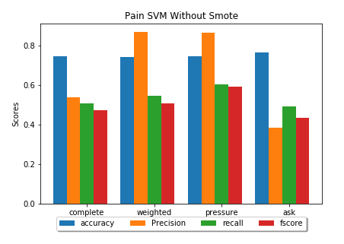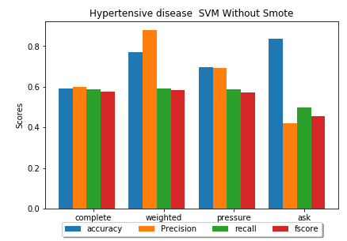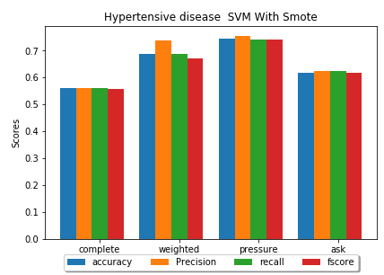

Figure 4 Pain SVM without SMOTENC

Figure 5 Hypertensive disease SVM without SMOTENC

Figure 6 Hypertensive disease SVM with SMOTENC

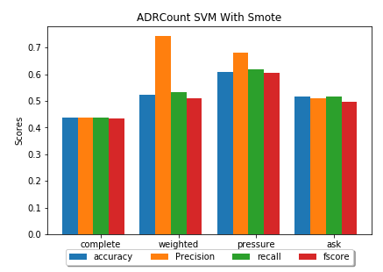

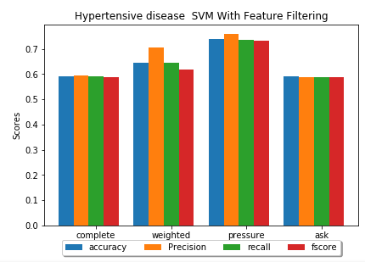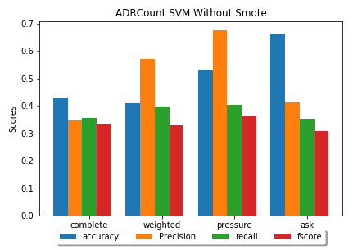

Figure 7 Hypertensive disease SVM with Feature Filtering

Figure 8 ADR Count Without SMOTENC

Figure 9 ADR Count with SMOTENC

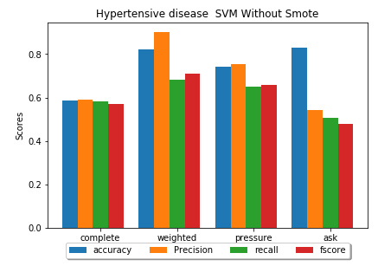

Figure 10 Hypertensive disease SVM with Feature Filtering without SMOTENC

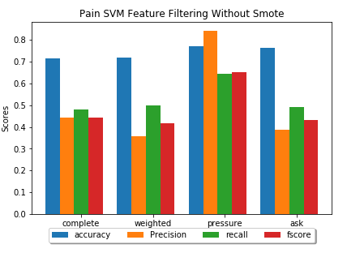

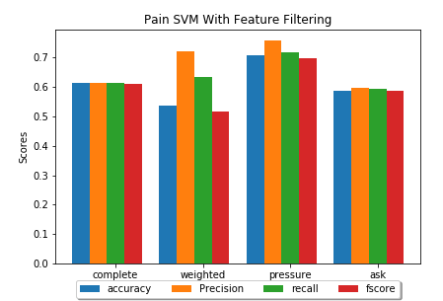

Figure 11 Pain SVM with Feature Filtering and SMOTENC

Figure 12 Pain SVM with Feature Filtering Without SMOTENC

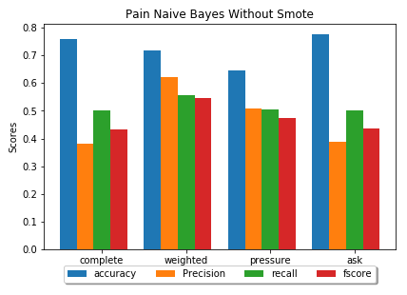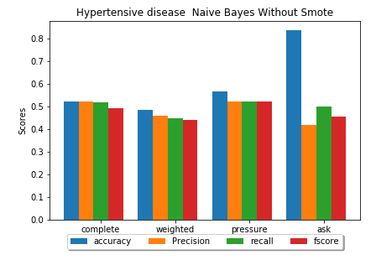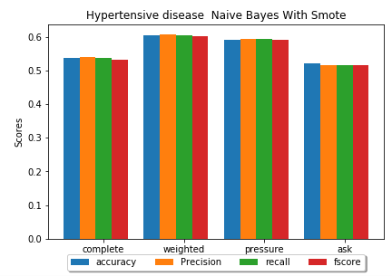

Figure 13 Pain NB Without Smote

Figure 15 Hypertensive Disease NB

Figure 14 Hypertensive Disease NB without SMOTENC

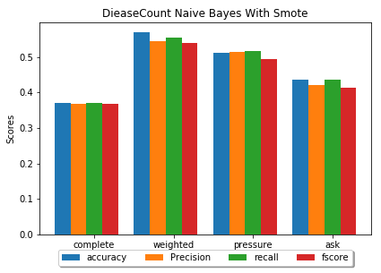

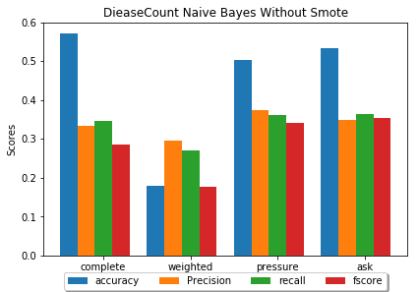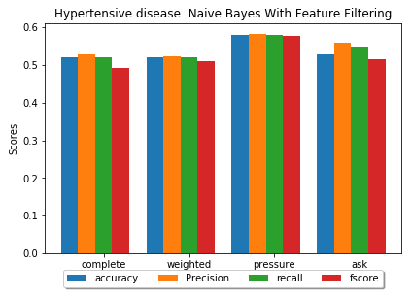

Figure 16 Hypertensive Disease NB with Feature Filtering

Figure 17 Disease Count NB without SMOTENC

Figure 18 Disease Count NB

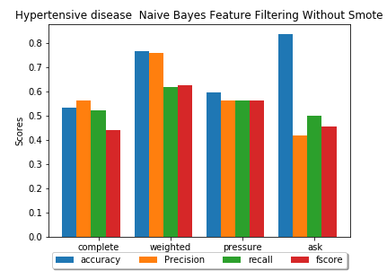

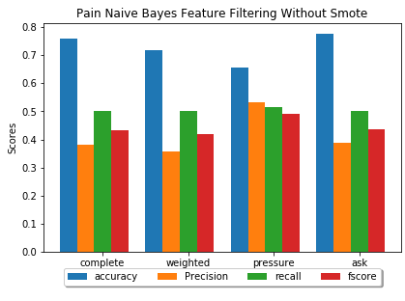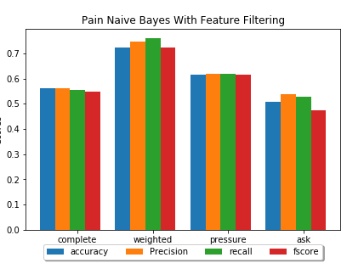

Figure 19 Pain NB with Feature Filtering without SMOTENC

Figure 20 Pain NB with Feature Filtering

Figure 21 Hypertensive Disease NB with Feature Filtering without SMOTENC

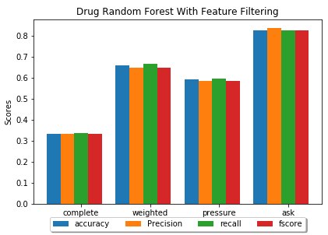

Figure 23 Drug Predictions Random Forest with Filtering

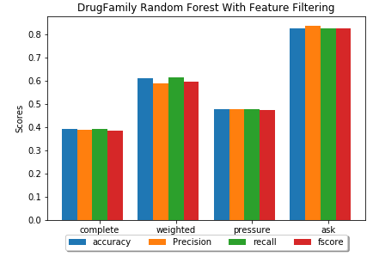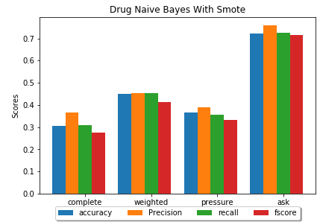

Figure 24 Drug Predictions with Naive Bayes

Figure 22 Drug Family predictions random Forest with feature filtering

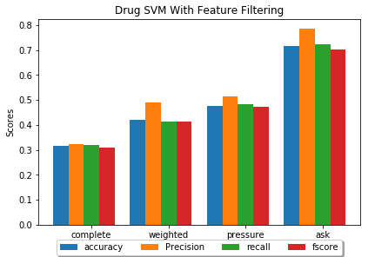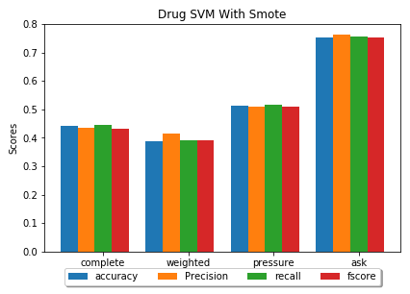

Figure 25 Drug prediction with SVM and Feature Filtering

Figure 26 Drug Predictions SVM

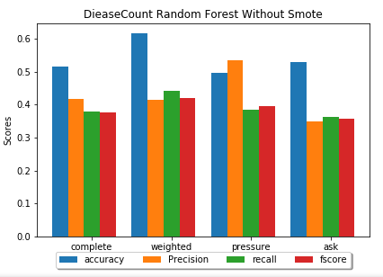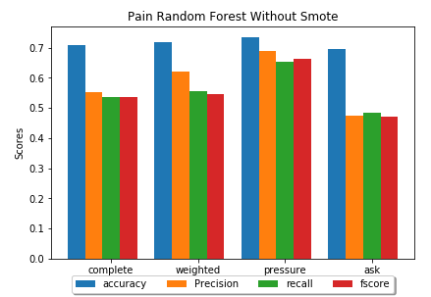

Figure 27 Disease Count RF with SMOTENC

Figure 28 RF Pain without SMOTENC

Figure 29 Disease Count RF without SMOTENC

# Appendix 2 – Tables of other results

|  |  |  |  |  |
| --- | --- | --- | --- | --- |
| **Datasets** | **Accuracy** | **Precision** | **Recall** | **FScore** |
| Complete | 0.709402 | 0.552477 | 0.536667 | 0.536188 |
| Weighted | 0.717949 | 0.621429 | 0.555195 | 0.546032 |
| Pressure | 0.733813 | 0.690711 | 0.652751 | 0.6622 |
| Ask | 0.696035 | 0.473708 | 0.483679 | 0.471291 |

*Table 1 RF Pain without SMOTENC*

|  |  |  |  |  |
| --- | --- | --- | --- | --- |
| **Datasets** | **Accuracy** | **Precision** | **Recall** | **FScore** |
| Complete | 0.423077 | 0.39879 | 0.388964 | 0.391975 |
| Weighted | 0.333333 | 0.330159 | 0.330159 | 0.329885 |
| Pressure | 0.561151 | 0.499906 | 0.482774 | 0.479719 |
| Ask | 0.559471 | 0.382987 | 0.3419 | 0.336909 |

*Table 2 RF DiseaseCount without SMOTENC*

|  |  |  |  |  |
| --- | --- | --- | --- | --- |
| **Datasets** | **Accuracy** | **Precision** | **Recall** | **FScore** |
| Complete | 0.514957 | 0.416226 | 0.377881 | 0.377375 |
| Weighted | 0.615385 | 0.415344 | 0.441414 | 0.42037 |
| Pressure | 0.496403 | 0.534444 | 0.384615 | 0.395995 |
| Ask | 0.528634 | 0.349699 | 0.363579 | 0.356326 |

*Table 3 RF ADR Count without SMOTENC*

|  |  |  |  |  |
| --- | --- | --- | --- | --- |
| **Dataset** | **Accuracy** | **Precision** | **Recall** | **FScore** |
| Complete | 0.587607 | 0.592206 | 0.583772 | 0.576133 |
| Weighted | 0.794872 | 0.763393 | 0.691558 | 0.711111 |
| Pressure | 0.726619 | 0.700376 | 0.707532 | 0.703258 |
| Ask | 0.819383 | 0.501885 | 0.500356 | 0.473377 |

*Table 4 Hypertensive Disease RF with Featuer Filtering and without SMOTENC*

|  |  |  |  |  |
| --- | --- | --- | --- | --- |
| **Dataset** | **Accuracy** | **Precision** | **Recall** | **FScore** |
| Complete | 0.677603 | 0.701309 | 0.668407 | 0.660118 |
| Weighted | 0.851852 | 0.857143 | 0.882353 | 0.85 |
| Pressure | 0.741294 | 0.740859 | 0.739424 | 0.739845 |
| Ask | 0.700565 | 0.711313 | 0.69165 | 0.689782 |

|  |  |  |  |  |
| --- | --- | --- | --- | --- |
| **Estimators** | **Accuracy** | **Precision** | **Recall** | **FScore** |
| Complete | 0.587607 | 0.592206 | 0.583772 | 0.576133 |
| Weighted | 0.794872 | 0.763393 | 0.691558 | 0.711111 |
| Pressure | 0.726619 | 0.700376 | 0.707532 | 0.703258 |
| Ask | 0.819383 | 0.501885 | 0.500356 | 0.473377 |

*Table 5 Pain RF With Feature Filtering and SMOTENC*

*Table 6 Pain RF with Feature Filtering and Without SMOTENC*

|  |  |  |  |  |
| --- | --- | --- | --- | --- |
| **Dataset** | **Accuracy** | **Precision** | **Recall** | **FScore** |
| Complete | 0.560878 | 0.562123 | 0.561012 | 0.558965 |
| Weighted | 0.6875 | 0.737363 | 0.6875 | 0.670179 |
| Pressure | 0.743902 | 0.753535 | 0.742674 | 0.74078 |
| AskAPatient | 0.619178 | 0.6234 | 0.623864 | 0.619132 |

*Table 7 Hypertensive disease SVM with SMOTENC*

|  |  |  |  |  |
| --- | --- | --- | --- | --- |
| **Dataset** | **Accuracy** | **Precision** | **Recall** | **FScore** |
| Complete | 0.59188 | 0.599346 | 0.5875 | 0.577272 |
| Weighted | 0.769231 | 0.878378 | 0.590909 | 0.584615 |
| Pressure | 0.697842 | 0.693343 | 0.587111 | 0.573744 |
| AskAPatient | 0.837004 | 0.418502 | 0.5 | 0.455635 |

*Table 8 Hypertensive disease SVM without SMOTENC*

|  |  |  |  |  |
| --- | --- | --- | --- | --- |
| **Dataset** | **Accuracy** | **Precision** | **Recall** | **FScore** |
| Complete | 0.745726 | 0.539855 | 0.508527 | 0.471888 |
| Weighted | 0.74359 | 0.868421 | 0.545455 | 0.507576 |
| Pressure | 0.748201 | 0.865385 | 0.602273 | 0.592034 |
| AskAPatient | 0.76652 | 0.386667 | 0.494318 | 0.433915 |

*Table 9 Pain SVM without SMOTENC*

|  |  |  |  |  |
| --- | --- | --- | --- | --- |
| **Dataset** | **Accuracy** | **Precision** | **Recall** | **FScore** |
| Complete | 0.436102 | 0.435908 | 0.43593 | 0.43584 |
| Weighted | 0.522727 | 0.742424 | 0.531746 | 0.509794 |
| Pressure | 0.608696 | 0.680497 | 0.618276 | 0.604497 |
| AskAPatient | 0.515766 | 0.509676 | 0.515725 | 0.495939 |

*Table 10 ADR Count with SMOTENC*

|  |  |  |  |  |
| --- | --- | --- | --- | --- |
| **Dataset** | **Accuracy** | **Precision** | **Recall** | **FScore** |
| Complete | 0.431624 | 0.347332 | 0.35475 | 0.334189 |
| Weighted | 0.410256 | 0.571895 | 0.398413 | 0.328704 |
| Pressure | 0.532374 | 0.674731 | 0.404633 | 0.360942 |
| AskAPatient | 0.665198 | 0.413203 | 0.351358 | 0.308581 |

*Table 11 ADR Count without SMOTENC*

|  |  |  |  |  |
| --- | --- | --- | --- | --- |
| **Dataset** | **Accuracy** | **Precision** | **Recall** | **FScore** |
| Complete | 0.58547 | 0.591346 | 0.58125 | 0.571671 |
| Weighted | 0.820513 | 0.9 | 0.681818 | 0.711111 |
| Pressure | 0.741007 | 0.753885 | 0.649611 | 0.656319 |
| AskAPatient | 0.828194 | 0.544283 | 0.505619 | 0.477175 |

*Table 12 Hypertensive disease SVM with Feature Filtering without SMOTENC*

|  |  |  |  |  |
| --- | --- | --- | --- | --- |
| **Dataset** | **Accuracy** | **Precision** | **Recall** | **FScore** |
| Complete | 0.590818 | 0.593961 | 0.590996 | 0.587638 |
| Weighted | 0.645833 | 0.706388 | 0.645833 | 0.617799 |
| Pressure | 0.737805 | 0.758133 | 0.736055 | 0.731567 |
| AskAPatient | 0.591781 | 0.588914 | 0.589318 | 0.589004 |

*Table 13 Hypertensive disease SVM with Feature Filtering*

|  |  |  |  |  |
| --- | --- | --- | --- | --- |
| **Dataset** | **Accuracy** | **Precision** | **Recall** | **FScore** |
| Complete | 0.614836 | 0.613653 | 0.612231 | 0.612088 |
| Weighted | 0.537037 | 0.722222 | 0.632353 | 0.516995 |
| Pressure | 0.706468 | 0.756909 | 0.717875 | 0.697821 |
| AskAPatient | 0.587571 | 0.597529 | 0.594078 | 0.585666 |

*Table 14 Pain SVM with Feature Filtering and SMOTENC*

|  |  |  |  |  |
| --- | --- | --- | --- | --- |
| **Dataset** | **Accuracy** | **Precision** | **Recall** | **FScore** |
| Complete | 0.536926 | 0.539222 | 0.537155 | 0.530853 |
| Weighted | 0.604167 | 0.60582 | 0.604167 | 0.602614 |
| Pressure | 0.591463 | 0.594377 | 0.592369 | 0.589617 |
| AskAPatient | 0.520548 | 0.516347 | 0.516364 | 0.516351 |

*Table 15 Hypertensive Disease NB*

|  |  |  |  |  |
| --- | --- | --- | --- | --- |
| **Dataset** | **Accuracy** | **Precision** | **Recall** | **FScore** |
| Complete | 0.553495 | 0.553395 | 0.553513 | 0.5532 |
| Weighted | 0.703704 | 0.720833 | 0.733824 | 0.702069 |
| Pressure | 0.626866 | 0.626733 | 0.62711 | 0.626533 |
| AskAPatient | 0.5 | 0.535696 | 0.520443 | 0.451768 |

|  |  |  |  |  |
| --- | --- | --- | --- | --- |
| **Dataset** | **Accuracy** | **Precision** | **Recall** | **FScore** |
| Complete | 0.523504 | 0.522391 | 0.517544 | 0.492884 |
| Weighted | 0.487179 | 0.458556 | 0.449675 | 0.442857 |
| Pressure | 0.568345 | 0.522665 | 0.522665 | 0.522665 |
| AskAPatient | 0.837004 | 0.418502 | 0.5 | 0.455635 |

*Table 16 Hypertensive Disease NB without SMOTENC*

|  |  |  |  |  |
| --- | --- | --- | --- | --- |
| **Dataset** | **Accuracy** | **Precision** | **Recall** | **FScore** |
| Complete | 0.760684 | 0.380342 | 0.5 | 0.432039 |
| Weighted | 0.717949 | 0.621429 | 0.555195 | 0.546032 |
| Blood | 0.647482 | 0.509409 | 0.504187 | 0.472874 |
| AskAPatient | 0.77533 | 0.387665 | 0.5 | 0.436725 |

*Table 17 Pain NB Without Smote*

*Table 18 Pain NB*

|  |  |  |  |  |
| --- | --- | --- | --- | --- |
| **Dataset** | **Accuracy** | **Precision** | **Recall** | **FScore** |
| Complete | 0.371648 | 0.369142 | 0.369659 | 0.369044 |
| Weighted | 0.568966 | 0.544067 | 0.553872 | 0.539088 |
| Blood | 0.512821 | 0.513312 | 0.516115 | 0.494191 |
| AskAPatient | 0.435967 | 0.421373 | 0.435923 | 0.412535 |

*Table 19 Disease Count NB*

|  |  |  |  |  |
| --- | --- | --- | --- | --- |
| **Dataset** | **Accuracy** | **Precision** | **Recall** | **FScore** |
| Complete | 0.57265 | 0.371117 | 0.343385 | 0.271581 |
| Weighted | 0.538462 | 0.342857 | 0.360606 | 0.350697 |
| Blood | 0.546763 | 0.367236 | 0.359568 | 0.287233 |
| AskAPatient | 0.506608 | 0.173454 | 0.316804 | 0.224172 |

*Table 20 NB Count without SMOTENC*

|  |  |  |  |  |
| --- | --- | --- | --- | --- |
| **Dataset** | **Accuracy** | **Precision** | **Recall** | **FScore** |
| Complete | 0.520958 | 0.527749 | 0.521434 | 0.492315 |
| Weighted | 0.520833 | 0.52277 | 0.520833 | 0.510421 |
| Blood | 0.579268 | 0.581915 | 0.580173 | 0.577367 |
| AskAPatient | 0.528767 | 0.560603 | 0.549848 | 0.515227 |

*Table 21 Hypertensive Disease NB with Feature Filtering*

|  |  |  |  |  |
| --- | --- | --- | --- | --- |
| **Dataset** | **Accuracy** | **Precision** | **Recall** | **FScore** |
| Complete | 0.534188 | 0.565179 | 0.524013 | 0.439921 |
| Weighted | 0.769231 | 0.760714 | 0.618506 | 0.628571 |
| Blood | 0.597122 | 0.562113 | 0.564332 | 0.562697 |
| AskAPatient | 0.837004 | 0.418502 | 0.5 | 0.455635 |

*Table 22 Hypertensive Disease NB with Feature Filtering without SMOTENC*

|  |  |  |  |  |
| --- | --- | --- | --- | --- |
| **Dataset** | **Accuracy** | **Precision** | **Recall** | **FScore** |
| Complete | 0.562054 | 0.560617 | 0.554822 | 0.547433 |
| Weighted | 0.722222 | 0.746844 | 0.758824 | 0.721362 |
| Blood | 0.616915 | 0.61735 | 0.617676 | 0.616764 |
| AskAPatient | 0.508475 | 0.538858 | 0.526307 | 0.474509 |

*Table 23 Pain NB with Feature Filtering*

|  |  |  |  |  |
| --- | --- | --- | --- | --- |
| **Dataset** | **Accuracy** | **Precision** | **Recall** | **FScore** |
| Complete | 0.760684 | 0.380342 | 0.5 | 0.432039 |
| Weighted | 0.717949 | 0.358974 | 0.5 | 0.41791 |
| Blood | 0.654676 | 0.533028 | 0.51555 | 0.489908 |
| AskAPatient | 0.77533 | 0.387665 | 0.5 | 0.436725 |

*Table 24 Pain NB with Feature Filtering without SMOTENC*

|  |  |  |  |  |
| --- | --- | --- | --- | --- |
| **Estimators** | **Accuracy** | **Precision** | **Recall** | **FScore** |
| Complete | 0.335125 | 0.334382 | 0.33591 | 0.333261 |
| Weighted | 0.66129 | 0.648049 | 0.668111 | 0.648689 |
| Pressure | 0.594982 | 0.586339 | 0.597276 | 0.585986 |
| Ask | 0.828877 | 0.836913 | 0.827197 | 0.827277 |

*Table 25 Drug Predictions Random Forest with Filtering*

|  |  |  |  |  |
| --- | --- | --- | --- | --- |
| **Estimators** | **Accuracy** | **Precision** | **Recall** | **FScore** |
| Complete | 0.392334 | 0.391084 | 0.393215 | 0.385144 |
| Weighted | 0.596774 | 0.575284 | 0.597724 | 0.582342 |
| Pressure | 0.477679 | 0.47844 | 0.478799 | 0.476218 |
| Ask | 0.828877 | 0.836913 | 0.827197 | 0.827277 |

*Table 26 Drug Family predictions random Forest with feature filtering*

*Table 27 Drug Predictions with SVM*

|  |  |  |  |  |
| --- | --- | --- | --- | --- |
| **Dataset** | **Accuracy** | **Precision** | **Recall** | **FScore** |
| Complete | 0.317204 | 0.324079 | 0.318835 | 0.308868 |
| Weighted | 0.419355 | 0.490196 | 0.413183 | 0.413526 |
| Blood | 0.476703 | 0.51323 | 0.481905 | 0.474449 |
| AskAPatient | 0.716578 | 0.784646 | 0.721712 | 0.701521 |

|  |  |  |  |  |
| --- | --- | --- | --- | --- |
| **Dataset** | **Accuracy** | **Precision** | **Recall** | **FScore** |
| Complete | 0.305556 | 0.364391 | 0.310105 | 0.273662 |
| Weighted | 0.451613 | 0.454023 | 0.454578 | 0.414229 |
| Blood | 0.365591 | 0.389339 | 0.354946 | 0.333318 |
| AskAPatient | 0.721925 | 0.757815 | 0.725803 | 0.714067 |

*Table 29 Drug Predictions with Naive Bayes*

|  |  |  |  |  |
| --- | --- | --- | --- | --- |
| **Dataset** | **Accuracy** | **Precision** | **Recall** | **FScore** |
| Complete | 0.443548 | 0.436758 | 0.445805 | 0.432164 |
| Weighted | 0.387097 | 0.414805 | 0.390319 | 0.390853 |
| Pressure | 0.512545 | 0.50988 | 0.515292 | 0.510708 |
| AskAPatient | 0.754011 | 0.761474 | 0.755729 | 0.752994 |

*Table 28 Drug prediction with SVM and Feature Filtering*